**PROJECT REPORT**

ON

**ROOM RENTAL SERVICES**

Submitted in partial fulfillment of the requirement

For the award of the degree of

**MASTER OF COMPUTER APPLICATIONS (M.C.A)**

Developed & Submitted By

**Rajnish Pandey**

(Enrolment No. 1307/19)

(Roll No: 190819)

(M.C.A Semester – VI)

**Academic Session: 2019 - 2022**

**Department Of Computer Science**

**School Of Information Science And Technology**

**Babasaheb Bhimrao Ambedkar University**

(A Central University)

Vidya Vihar Raebareli Road, Lucknow - 226025

**Under the Supervision Of**

**Internal Project Guide External Project Guide**

**Dr. Shalini Chandra Mr. Pankaj Mishra**

**Assistant Prof. Department Of Computer Science Project Co-ordinator( Analyze Infotech )**

**Candidate Declaration**

I hereby declare that the work that is being presented in the project work entitled **“Room** **Rental Services**” for award of the degree of Master of Computer Application and submitted in the Department of Computer Science of **Babasaheb Bhimrao Ambedkar University** is an authentic record of my work carried out during the period of January 2022 to May 2022 under the supervision of **Dr. Shalini Chandra (Assistant professor)**, Department of Computer Science.

The matter embodied in the project is a genuine work done by me and has not been submitted to any other university for the fulfillment of the requirement of any degree/diploma.

Place:- Lucknow Rajnish Pandey

(Roll no:- 190819)

This is to certify that the above statement made by the candidate is correct to the best of my knowledge.

Date:- (Signature of Supervisor)

The Viva examination of Rajnish Pandey has been held on _________________ at ______________________________________________________________

(Signature of Head of the Department) (Signature of Examiner)

Prof. Sanjay Kumar Dwivedi

Professor

DCS, BBAU

Lucknow

## CANDIDATE’S DECLARATION

I hereby declare that the work presented in the report entitled “ROOM RENTAL SERVICES” in partial fulfillment of the requirement for the award of degree in Master of Computer Applications (M.C.A) of Department of Computer Science, Babasaheb Bhimrao Ambedkar University, Lucknow is an authentic work and was carried out by me.

I have not submitted the matter embodied in this report for the award of any other degree or diploma of any other University or Institute.

I have given due credit to the original authors/sources for all the words, ideas, diagrams, graphics, computer programs, experiments, results, that are not my original contribution.

Name: Rajnish Pandey

Enrollment No. 1307/19

Roll No. 190819

Place: Lucknow (Signature of Candidate)

**CERTIFICATE**

This is to certify that **Rajnish Pandey (Enroll No: 1307/19)** has carried out

the project work presented in this report entitled **“Room Rental Services”** for the award **of Master of Computer Application** from **Babasaheb Bhimrao Ambedkar Uiversity, Lucknow** under my/our supervision. The project embodies result of original work, and studies are carried out by the student himself and the contents of the project do not form the basis for the award of any other degree to the candidate or to anybody else from this or any other University/ Institution.

…………………………... …………………………...

Signature of the Guide Signature of the H.O.D

**[ Dr. Shalini Chandra ]** **[ Prof. Sanjay Kumar Dwivedi ]**

**Assistant Professor** **Head of the Department, D.C.S**

**CERTIFICATE**



**ACKNOWLEDGEMENT**

With the submission of this project I would like to express my gratitude towards all those people who provided me with their valuable assistance in the course of completion of the project.

It gives me immense pleasure in submitting this project **“Room Rental Services”.** I have developed this project as a major project for M.C.A 6th Semester.

I am highly grateful to almighty God for giving me required knowledge to finish my project and I wish to express my profound gratitude and sincere thanks to **Dr. SHALINI CHANDRA** my project guide without whose valuable guidance and constructive criticism this project would have been impossible. I am highly grateful to all the **Teachers** of the **Department of Computer Science** for their constant support and guidance.

I am grateful to my family and to all my friends who helped me in making this project possible with their positive and enthusiastic attitude towards me.

At last but not the least I consider myself proud to be a part of Department of Computer Science, Babasaheb Bhimrao Ambedkar University, Lucknow.

**RAJNISH PANDEY**

**Date: 08/06/2022**

**Place: Lucknow**

**TABLE OF CONTENTS**

|  |  |  |
| --- | --- | --- |
| S. No | Topic | Page No. |
| 1. | Introduction |  |
| 2. | Scope |  |
| 3. | Objective |  |
| 4. | Problem Definition |  |
| 5. | Purpose |  |
| 6. | Existing System |  |
| 7. | Proposed System |  |
| 8. | Feasibility Study |  |
| 9. | Software Requirement Specification |  |
| 9.1 | Tools to be used |  |
| 9.2 | Hardware Requirements |  |
| 9.3 | Software Requirements |  |
| 10. | System analysis & design |  |
| 10.1 | Project Model Used |  |
| 10.2 | System design approach |  |
| 10.3 | Module Description |  |
| 10.4 | Database design |  |
| 10.5 | Data Flow Diagram |  |
| 10.6 | ER Diagram |  |

|  |  |  |
| --- | --- | --- |
| 11. | Coding & Testing |  |
| 11.1 | Codes |  |
| 11.2 | Screenshots |  |
| 12. | Conclusion |  |
| 13. | Future Scope |  |
| 14. | Bibliography |  |

1. **INTRODUCTION**

Room booking is a part of e-commerce. E-commerce or business through internet means search room, book room and servicing of products or services over electronic system such as the internet and other computer networks. Thus, if we own a business, we need to upload menu online to attract potential customer.

The online room booking system gives ability to increase bookings and expand business by giving customers the facility to book room online. With an online room rental system, customers can book room online anytime from anywhere. Thus, it is a simple, fast and convenient room booking system giving an edge over the competition at an affordable price.

This “Room Rental System” will provide the information about Room/Flats/Houses which is available for rent. It will make easy to find the location of Room/Flats/Houses, select no. of rooms and other facts by the renter. It will make easy to upload the images, contact No., accepted rent, no. of rooms, facilities and information by landlord/room-master. Also, we can easily track the facility, maintain customer’s database and improve the room facility services. We can receive booking requests directly through internet or e-mails.

This room rental service allows you to search for your new home and book instantly. Through this service system one can very easily get the virtual viewings of the room before booking. As soon as booking request is sent by the customer to the service provider, the booking confirmation status will let the customer know whether his request is pending, not booked or confirmed. These rooms are available at per day bases and are within the normal price range which is categorized based on its type. The rooms are categorized into three types such as for a single person there is single room, for couples there are separate rooms for couples and for family there are other rooms for family to reside. Every room has basic amenities like air conditioner, wifi, drinking water, electricity etc. This room rental service system provides ease for the customers to book their rooms from all over the world with no registration charges. Only what is to be done is to fill a simple registration form with contact details. On registration, the customer will be redirected automatically to the home page where he can easily search rooms based on its category and purpose. For easy search, search room facility is there which shows the number of rooms based on its price and category. In order to book the rooms available few details of the customer will have to be given and will have to send a booking request. As soon as the booking request is sent the customer will find its booking request status there. For making this service better day by day it has a feedback form where one can give the feedback. For the registered users there is also change password facility where they can change their password and also update their profile.

Talking about the admin login section, the admin can see all rooms there. There is an add room functionality through which the admin can add new rooms on availability of new rooms and fill details such as room number, its type, photo, status whether booked or not etc. Search functionality for the admin allows him to search room number wise and see its availability or not. The admin can also delete the room or manage it by changing its details and status. He can also see all users who have registered themselves through their contact numbers. In view all bookings, the admin will see all booking requests and shall act accordingly whether to confirm or to cancel them. The admin in feedback section will find the feedbacks from the customers. He can also see contact details of the unregistered users who tried to contact the service provider. As soon as the booking is confirmed by the service provider the customer will get to know the current status of their booking request on their booking section.

Room rental service makes easy for the people to book rooms before leaving home and arriving at the destination. So, giving the business an online presence has become very crucial and important.

1. **SCOPE**

The scope of this system is very broad in terms of manually working system.

In a very short time the collection of data will be obvious, simple and sensible. As this is a generic software it can be used by a wide variety of room to automate the process of manually maintaining the records related to the subject of maintaining the entries and updating these records that too in a single click. It has a simple user interface thus it is easy to understand by the user. The procedure to search the room on the basis of different categories, prices, room no. makes the process to go on smoothly.

A normal user can book the room of the apartment/hotel with just a simple mouse click, thus the system process is fast and efficient and also it is easily expandable.

1. **OBJECTIVE**

Today’s world is the world of computers, because most of work is being done with the help of computer. Dependency on computer is behind the few reasons. We cannot easily manage to store large number of data or information single handle. If we will be in need of some information or data in urgency then we cannot manage it manually. These works are very difficult if we cannot use computer.

As the generic software it can be used by a wide variety of users to automate the process of booking of rooms and manually maintaining the records of each personal room. This software is basically updating the manual work of systems. So that organization can manage and organize their record in efficient and easy manner.

The main objective of the project is:

* To provide anytime/ anywhere online registration.
* To develop software that facilitates the data storage, data maintenance and its retrieval for the room in an efficient way.
* To search for the room on the basis of categories and prices
* To book a room with just a simple mouse click.
* To store the records of each customers.
* To add and manage room details efficiently.
* To save manpower.
* To speed the processing of data and transaction.
* To provide best security features such as data hiding of passwords .
* To develop a user friendly system that requires minimal user training.

1. **PROBLEM DEFINITION**

At present there are many online room booking systems that maintain their day to day transactions manually. These have a number of consumers, staff as a result they need to track of all these clients requirements. At this point ROOM RENTAL SERVICES will play an important role in helping the admin to perform all these operation on a single click. This project will handle all the necessary data as well as every minute detail of the rooms and users properly.

1. **PURPOSE**

The purpose of this document is to specify requirements and to give guidelines for the development of about said project. In a particular it gives guidelines on how to prepare the above said project. The old system was suffering from a series of the drawbacks. Since whole system was to be maintained with hands, the process of keeping, maintaining and retrieving the information was very tedious and lengthy, the record were never used to be in a systematic order as a result their used to be lot of difficulties and in associating particular transaction with a particular context. If any information was to be found it was required to go through different registers, documents that would never exist anything like report generation. There would be unnecessary consumption of time while entering records and retrieving the record . One more problem was that it was very difficult to find error while entering records as a result if one record was entered then it was difficult to update these records.

In the existing system the users were not able to book the rooms efficiently, because of the complex UI and the complex procedures in booking the room.

The admin were also not able to manage the details of the rooms and the customers.

To avoid all such complexities and difficulties this room rental services system will be beneficial for both i.e. the users and the room renters.

1. **Existing System:**

At present, various room booking systems maintain their day-to-day transactions manually. These have hundreds of rooms that need to be tracked of all its details like image, price, category, status etc. To find the product is also another risky job and this also applies for in finding the details of the customer. So a proper system is required. They need full pledged software to maintain their day-to-day transactions.

1. **Proposed System:**

The proposed system helps them in many ways. It helps them do billing very easily. Account maintenance also becomes easier. They can keep track of their booking room request’s status, the rooms whether it is available or not, and the account details of the customers and many more. The software is provided with all the master entries to enter any new room, or to modify the details of the existing room, to see all the customer or users, to modify and delete them from the system. To search for the room on the basis of categories and prices, to book a room with just a simple mouse click, to store the records of each customers, to add and manage room details efficiently and finally to save manpower.

1. **Feasibility Study**

Feasibility study is the second step of the system development life cycle. Things are always easy at the beginning in any software process. In fact nothing is in feasible with unlimited time and resources. But it is not the fact. So, practically we have to do in limited resources in a restricted time margin. So for the system to be feasible, following points we have to consider.

The feasibility study is conducted to check whether the candidate system is feasible. The system which is selected to be the best against the criteria is there after designed and developed. The feasibility study takes in to consideration, the risks involved in the project development beforehand. Therefore in this phase we have to do feasibility study which is the test of the website according to its work ability, impact on the organization, ability to meet user need and effective use of resources. We do the feasibility study for website to analyze the risks, costs and benefits relating to economics, technology and user organization. There are several types of feasibility depending on the aspect they cover. Important of these includes:

1. **Technical Feasibility:**

This is an important outcome of preliminary investigation. It comprise of following questions:-

Can the work of project be done one with the current equipment, existing software and available man power resource?

If Technology is required what are the possibilities that it can be developed?

As we know the technical feasibility is concerned with specifying equipment and software that will successfully satisfy the user requirement. The technical needs of the system may vary considerably, but might include:

* The facility to produce outputs of advertisements, booking and mailing in a given time for ease of use.
* Response time under certain condition is minimal.
* Ability to process a certain volume of transaction at a particular speed.
* Facility to communicate data to distinct location.

**2) Economic Feasibility:**

It deals with question related to the economy. It comprise of the following questions:-

* Are there sufficient benefits in creating the system to make the cost acceptable?
* Are the costs of creating the system so great that the project must be undertaken?

Economic analysis is the most frequently used technique for evaluating the effectiveness of the proposed system. More commonly known as cost/benefits analysis, the procedure is to determine the benefits and savings that are expected from the purposed system and compared with costs.

**3) Legal Feasibility:**

Legal feasibility is necessary to check that the software we are going to develop is legally correct which means that the ideas which we have taken for the proposed system will be legally implemented or not, so it is also an important step in feasibility study.

It deals with the question related to the legal issues. It comprise of the following questions:-

* Contract Signing
* Software License agreement
* Issues related to cyber laws.
* Legal issues relating to the man power contract.

**4) Operational Feasibility:**

The operational feasibility consists of the following activity:-

Will the system be useful if it is developed &implemented? Will there be resistance from employee?

Are current business methods acceptable to the user? If they are not, user may welcome a change that will bring about a more operational and useful system.

Have the user been involved in the planning and development of the Project? If they are involved at the earliest stage of project development, the chances of resistance can be possibly reduced.

Will the proposed system cause harm? Will it produce poorer result in any case or area?

**5) Social & Behavioural Feasibility:**

It deals with the various issues related to the human behaviour like:-

* Whether the user be able to adapt a new change or not?
* Whether the ambiance we are providing suits the user or not?

1. **SOFTWARE REQUIREMENT SPECIFICATION**

A requirements specification for a software system is a complete description of the behaviour of a system to be developed and it includes a set of use cases that describe all the interactions the users will have with the software. In addition to use cases, the SRS also contains non-functional requirements.

**Non-functional requirements** are requirements which impose constraints on the design or implementation (such as performance engineering requirements, quality standards, or design constraints).Requirements are a sub-field of software engineering that deals with the elicitation, analysis, specification, and validation of requirements for software. In this Software, Input error will be returned in red with appropriate message box. System should automatically update after every transaction.

**Functional Requirement**: This Software must request Username and Password for access to data, only after authentication, will allow access to the system. The Software must allow input of rooms data from administrator and secured access.

The software requirement specification document enlists all necessary requirements for project development. To derive the requirements we need to have clear and thorough understanding of the products to be developed. This is prepared after detailed communications with project team and the customer.

**TOOLS TO BE USED:**

**1)Python Introduction**: Python is a general purpose, dynamic, high level, and interpreted programming language. It supports object-oriented programming approach to develop applications. It is simple and easy to learn and provide lots of high-level data structures.

Python is easy to learn yet powerful and versatile scripting language, which makes it attractive for application development.

Python’s syntax and dynamic typing with its interpreted nature make it an ideal language for scripting and rapid application development.

Python supports multiple programming pattern, including object-oriented, imperative, and functional or procedural programming styles.

Python is easy to learn and use. It is developer-friendly and high-level programming language.

Python is understandable and readable. Python is an interpreted language i.e.; interpreter executes the code line by line at a time.

Python can run equally on different platforms such as windows, Linux, Unix etc. so, we can say that python is a portable language.

Python language is freely available. It is open source.

Python supports object oriented language and concept of classes and objects come into existence. Python has a large library and provides rich set of module and functions for rapid application development.

**2) Django**: - Django is a python-based free and open-source web framework that follows the Model-Template-Views (MTV) architectural pattern. Django emphasizes reusability of components, also referred to as DRY (Don’t Repeat Yourself), and comes with ready-to-use features like login system, database connection and CRUD operations (Create Read Update Delete).

**Model:** The model provides data from the database. In Django, the data is delivered as an Object Relational Mapping (ORM), which is a technique designed to make it easier to work with databases. The most common way to extract data from a data from a database is SQL. Django, with ORM, makes it easier to communicate with the database, without having to write complex SQL statements. The models are usually located in a file called models.py.

**Syntax**: - from django.db import models

class ModelName(models.Model):

field_name = models. Field(**options)

**View**:- A view is a function or method that take http requests as arguments, imports the relevant model(s), and finds out what data to send to the template, and returns the final result. The views are usually located in a file called views.py.

**Syntax**: - from django.shortcuts import render

def var(request):

return render(request,'hello.html')

**URLs** :- Django also provide a way to navigate around the different pages in a website. When a user requests a URL, Django decides which view it will send it to. This done in a file called urls.py.

**Syntax:** - from django. contrib import admin

from django.urls import path

from app import views

urlpatterns = [ path ('admin/', admin.site.urls),

path ('‘, views.var,name=’views’) ]

**Template** :- A template is a file where you describe how to the result should be represented. Template are often .html files, with HTML ,CSS, Bootstrap code describing the layout of a web page, but it can also be in other file formats to present other results like XML, CSV.

A template is rendered with a context. Rendering replaces variable with their value, which are looked up in the context, and executes tags. Everything else is output as is.

The syntax of the Django template language involves four constructs variables

A variable outputs a value from the context, which is a dict-like object mapping key to values.

Variables are surround by {{ and }} like this: My first name is {{ first_name }} . My last name is {{ last_name }} . With a context of {‘first_name’: ‘Jenna’, ‘last_name’: ‘Doe’}, this template renders to: My first name is Jenna. My last name is Doe

**Tags**:- Tags provide arbitrary logic in the rendering process. The definition is deliberately vague. For example, a tag can output content, serve as a control structure e.g. an “if” statement of a “for”loop, grab content from a database, or even enable access to other template tags.

Tags are surrounded by {%and%} like this: {% csrf_token %} {% if user.is_authenticated %} Hello, {{ user.username }}. {%endif%}

**Filters**:- Filters transform the value of the variable and tag arguments. They look like this: {{ django|title }}

**Configuration**:- Templates engines are configured with the TEMPLATES setting. It’s a list of configurations, one for each engine.

TEMPLATES = [ { 'BACKEND': 'django.template.backends.django.DjangoTemplates', 'DIRS': ["templates"],

'APP_DIRS': True,

'OPTIONS': {

'context_processors': [ 'django.template.context_processors.debug',

'django.template.context_processors.request',

'django.contrib.auth.context_processors.auth',

'django.contrib.messages.context_processors.messages',

], }, }, ]

**Django create project:**

Firstly install Django by pip command. Then create a folder, folder name Django once the folder is created, create a folder named HTTP response inside it. And then by going inside the HTTP response folder and clicking in its address bar, type CMD. After open command prompt the project will start by given command.

1. C:\django\httpresponse>django-admin startproject projectd

2. C:\django\httpresponse>cd projectd

3. C:\django\httpresponse\projectd>python manage.py startapp app

4. C:\django\httpresponse\projectd>code .

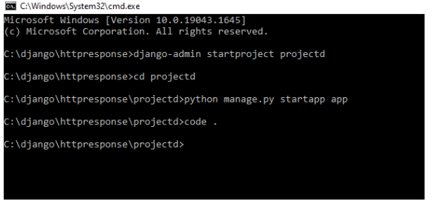

**Create App**

An app is a web application that has a specific meaning in project, like home page, a contact form, or a members database.

My app name is app

C:\django\httpresponse\projectd>**python manage.py startapp app**

Django creates a folder named app in my project, with this content:

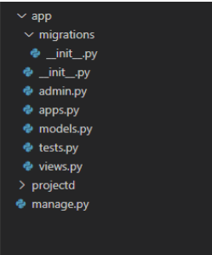

These are all file and folder with a specific meaning. Django-admin and manage.py

First open new terminal and type python manage.py runserver

This provide local host development server at http://127.0.0.1:8000/ the output is shown on web browser.

**Migrate,** which is responsible for applying and unapplying migrations. **Makemigrations**, which is responsible for creating new migrations based on the changes you have made to your migration.

**Create superuser in Django:**

Python manage.py createsuperuser

Now Django will prompt you to enter the details, enter details and hit enter. Username (leave blank to use ‘admin’): admin

Email address: [abc@gmail.com](mailto:abc@gmail.com)

Password: ********

Password (again):********

Superuser created successfully. Now that the superuser is created, run the development server.

Python manage.py runserver Open the browser and navigate to http://127.0.0.1:8000/admin/ You should see a login page, enter the details you provided for the superuser.

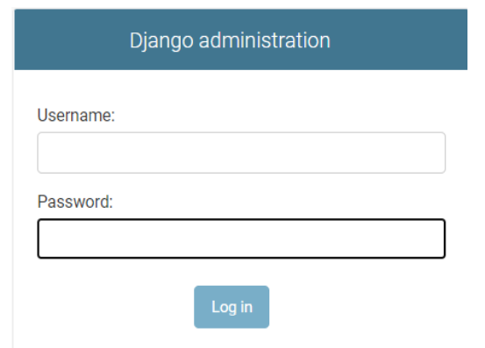

**3) IntelliJ IDLE Introduction:**

IntelliJ IDEA is an *Integrated Development Environment (IDE)* for JVM languages designed to maximize developer productivity. It does the routine and repetitive tasks for you by providing clever code completion, static code analysis, and refactorings, and lets you focus on the bright side of software development, making it not only productive but also an enjoyable experience.

**Features:**

• Coding assistance and analysis, with code completion, syntax and error highlighting, linter integration, and quick fixes

• Project and code navigation: specialized project views, file structure views and quick jumping between files, classes, methods and usages

• Python refactoring: includes rename, extract method, introduce variable, introduce constant, pull up, push down and others

• Integrated Python debugger

• Integrated unit testing, with line-by-line code coverage

• Google App Engine Python development [professional edition only]

• Support for scientific tools like Matplotlib, NumPy and SciPy [professional edition only]

• It competes mainly with a number of other Python-oriented IDEs.

**4) SQLite**: SQLite is an in-process library that implements a self-contained, serverless, zeroconfiguration, transactional SQL database engine. It is a database, which is zeroconfigured, which means like other databases you do not need to configure it in your system.

SQLite engine is not a standalone process like other databases, you can link it statically or dynamically as per your requirement with your application. SQLite accesses its storage files directly.

• SQLite does not require a separate server process or system to operate (serverless).

• SQLite comes with zero-configuration, which means no setup or administration needed.

• A complete SQLite database is stored in a single cross-platform disk file.

• SQLite is very small and light weight, less than 400KiB fully configured or less than 250KiB with optional features omitted.

• SQLite is self-contained, which means no external dependencies.

• SQLite transactions are fully ACID-compliant, allowing safe access from multiple processes or threads

. • SQLite supports most of the query language features found in SQL92 (SQL2) standard.

• SQLite is written in ANSI-C and provides simple and easy-to-use API.

• SQLite is available on UNIX (Linux, Mac OS-X, Android, iOS) and Windows (Win32, WinCE, WinRT). SQLite Limitations

There are few unsupported features of SQL92 in SQLite which are listed in the following table.

|  |  |
| --- | --- |
| **Sr.No** | **Features & Description** |
| 1 | **RIGHT OUTER JOIN**  Only LEFT OUTER JOIN is implemented. |
| 2 | **FULL OUTER JOIN**  Only LEFT OUTER JOIN is implemented. |
| 3 | **ALTER TABLE**  The RENAME TABLE and ADD COLUMN variants of the ALTER TABLE  command are supported. The DROP COLUMN, ALTER COLUMN, ADD  CONSTRAINT are not supported. |
| 4 | **Trigger support**  FOR EACH ROW triggers are supported but not FOR EACH STATEMENT triggers. |
| 5 | **VIEWs**  VIEWs in SQLite are read-only. You may not execute a DELETE, INSERT, or UPDATE statement on a view. |
| 6 | **GRANT and REVOKE**  The only access permissions that can be applied are the normal file access permissions of the underlying operating system. |

**Hardware Requirements:**

The most common set of requirements define by any operating system or software application is the physical computer resource, also known as hardware. A hardware requirement list is often accompanied by a hardware compatibility list, especially in case of operating system. Compatibility and sometimes incompatible hardware device for a particular operating or application. The following sub-sections discuss the various aspects of hardware requirements.

• Recommended minimum CPU- Pentium IV Processor

• Recommended minimum 8 GB RAM

• Minimum 150 GB HDD space for a typical live system

• Color Monitor

• Keyboard, Mouse

**Software Requirements:**

Software requirements deal with defining software resource requirement and pre-requisites that need to be installed on a computer to provide optimal functioning of an application. These requirements or pre-requisites are generally not included in the software installations package and need to be installed separately before the software is installed.

• Operating system: windows 10,8,7

• Django 4.0.1

• Python 3.9.6

• Any text editor ( Sublime,Notepad++ )

• Database – SQLite

• HTML, CSS, Bootstrap, JavaScript

* IDLE (Pycharm, IntelliJ )

1. **System Design:**

**Develop High-Level Design and Low level Design before execution**

* Built a design of all the processes required for the project.
* Developed the architecture of the software solution.
* Developed the project design in detail for the software developer in the company.

**PROJECT MODEL USED**

**Iterative Enhancement Model**

* This model has the same phases as the waterfall model, but with fewer restrictions.
* Generally the phases occur in the same order as in the waterfall model, but they may be conducted in several cycles.
* Useable product is released at the end of the each cycle, with each release providing additional functionality. Customers and developers specify as many requirements as possible and prepare a SRS document. Developers and customers then prioritize these requirements. Developers implement the specified requirements in one or more cycles of design, implementation and test based on the defined priorities.

The procedure itself consists of the initialization step, the iteration step, and the Project Control List. The initialization step creates a base version of the system.

The goal for this initial implementation is to create a product to which the user can react. It should offer a sampling of the key aspects of the problem and provide a solution that is simple enough to understand and implement easily. To guide the iteration process, a project control list is created that contains a record of all tasks that need to be performed. It includes such items as new features to be implemented and areas of redesign of the existing solution. The control list is constantly being revised as a result of the analysis phase.

The iteration involves the redesign and implementation of iteration is to be simple, straightforward, and modular, supporting redesign at that stage or as a task added to the project control list. The level of design detail is not dictated by the iterative

approach. In a light-weight iterative project the code may represent the major source of documentation of the system; however, in a critical iterative project a formal Software Design Document may be used. The analysis of an iteration is based upon user feedback, and the program analysis facilities available. It involves analysis of the structure, modularity, usability, reliability, efficiency, & achievement of goals. The project control list is modified in light of the analysis results

**PHASES:**

Incremental development slices the system functionality into increments (portions). In each increment, a slice of functionality is delivered through cross-discipline work, from the requirements to the deployment. The unified process groups increments/iterations into phases: inception, elaboration, construction, and transition.

* Inception identifies project scope, requirements (functional and non-functional) and risks at a high level but in enough detail that work can be estimated.
* Elaboration delivers a working architecture that mitigates the top risks and fulfills the non-functional requirements.
* Construction incrementally fills-in the architecture with production-ready code produced from analysis, design, implementation, and testing of the functional requirements.

Transition delivers the system into the production operating environment.

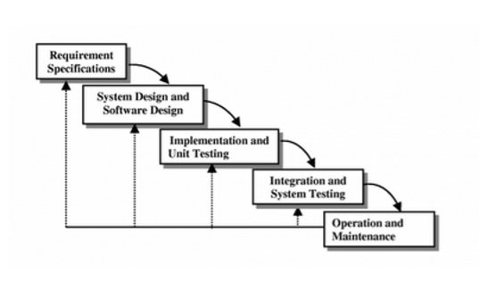

**SYSTEM DESIGN APPROACH**

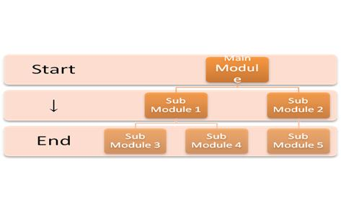**Top – Down designing:** The top - down designing approach started with major components of the system. It is a stepwise refinement which starts from an abstract design, in each steps the design is refined two or more concrete levels until we reach a level where no – more refinement is possible or not needed.



**Bottom – Up designing:**

In bottom – up designing the most basic and primitive components are designed first, and we proceed to higher level components. We work with layers of abstractions and abstraction are implemented until the stage is reached where the operations supported by the layer is complete.



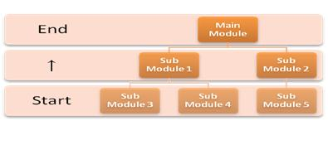

**Approach we are following:**

In this project we are following **Mixed Approach** i.e. a combination of top – down and bottom – up. We are developing some of the components using top – down designing approach (e.g. the templates) and the some components in bottom – up designing approach (e.g. the middle tier classes).

**MODULE DISCRIPTION**

**1.Register User :**

The User fills the registration form by giving the personal information and successfully registers with the website.

**2. Login:**

The ROOM BOOKING SYSTEM first activates the login page. Here the user enters USER NAME AND PASSWORD and the system starts authentication process in which the USER NAME AND PASSWORD is matched with the existing USER NAME AND PASSWORD in the database. If the password matches then it is allowed to the main page else it warns the user for invalid USER NAME AND PASSWORD. After the successful authentication the system activated menus. The activity log also prepared for failure and security There are two types of users using this software i.e., admin,customer.

Admin (Description/Images/Status) :After entering into admin home page will add new room by filling add room form, by providing sufficient details about room such as room number, available dates, rent etc and upload the image of that room or house .

**3.Update Room**

Admin can update the existing room details such as rent, available dates, etc.

***Update Product:*** Admin can update the existing room details such as rent, available dates, etc.

***Delete Product:*** admin can also delete the room.

**4.Data base maintenance**

The data provided by the admin such as room details, personal details, etc. and data provided by the customer such as feedback and booking details will be maintained in a data base.

**5.Searching and Booking the room**

The Customer after accessing the site searches for room, if he/she finds the required room then he/she need to fill the signup form and submit to the database.

**6.Authentication**

Authentication is nothing but providing security to the system . Here everyone must enter into the system through login page.

**Database Design:**

**List of Tables:**

* Signup
* Contact
* Room
* Booking
* Feedback

**Signup table**

**class** Signup(models.Model):  
 user=models.ForeignKey(User,on_delete=models.CASCADE)  
 mobile = models.CharField(max_length=20,null=**True**)  
 gender = models.CharField(max_length=20,null=**True**)  
 image = models.FileField(null=**True**)  
 dob = models.CharField(max_length=10,null=**True**)  
 address = models.CharField(max_length=50,null=**True**)  
 **def** _str_(self):  
 **return** self.user.username

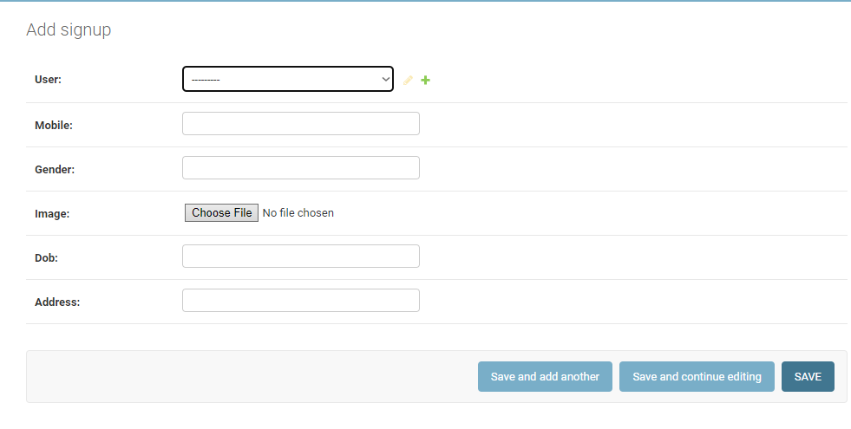

**Contact table**

**class** Contact(models.Model):  
 name=models.CharField(max_length=30,null=**True**)  
 contact=models.CharField(max_length=30,null=**True**)  
 email=models.CharField(max_length=30,null=**True**)  
 purpose=models.CharField(max_length=50,null=**True**)

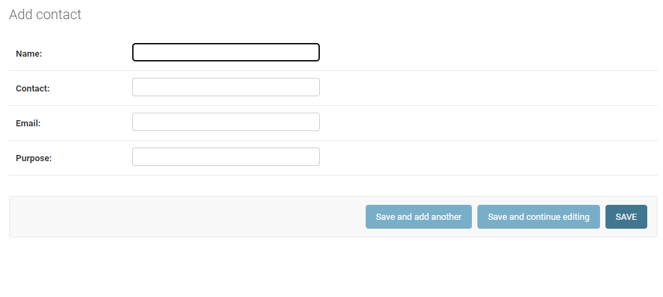

**Room table**

**class** Room(models.Model):  
 room_no = models.IntegerField(max_length=20,null=**True**)  
 price = models.CharField(max_length=20,null=**True**)  
 type = models.CharField(max_length=20,null=**True**)  
 image = models.FileField(max_length=20,null=**True**)  
 status = models.CharField(max_length=20,null=**True**)

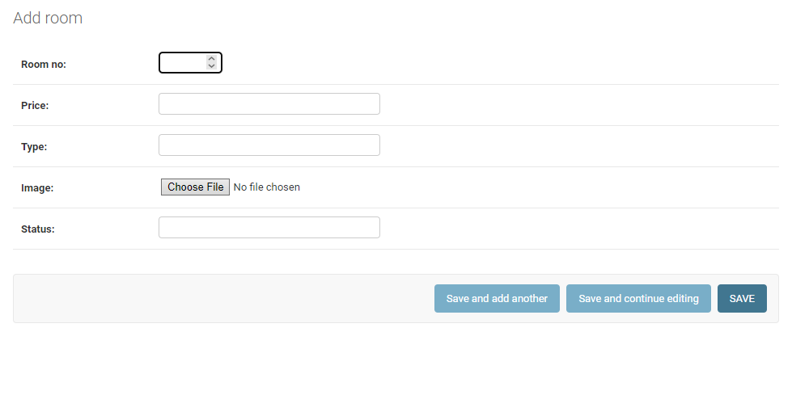

**Booking table**

**class** Booking(models.Model):  
 room_no=models.CharField(max_length=20,null=**True**)  
 user_name=models.CharField(max_length=30,null=**True**)  
 user_email=models.CharField(max_length=30,null=**True**)  
 contact1=models.CharField(max_length=30,null=**True**)  
 contact2=models.CharField(max_length=30,null=**True**)  
 booking_date=models.CharField(max_length=30,null=**True**)  
 days=models.CharField(max_length=20,null=**True**)  
 gender=models.CharField(max_length=20,null=**True**)  
 price=models.CharField(max_length=20,null=**True**)  
 dob=models.CharField(max_length=20,null=**True**)  
 status=models.CharField(max_length=20,null=**True**)

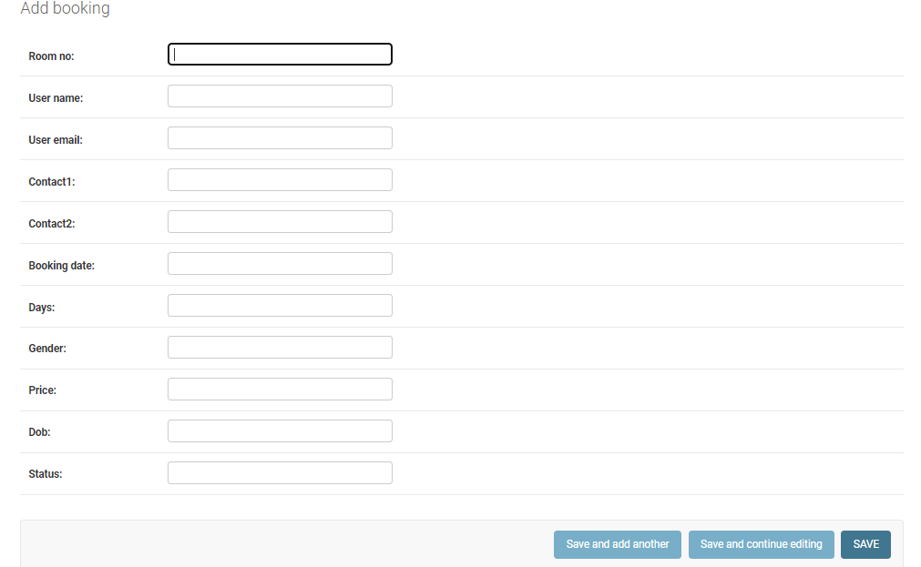

**Feedback table**

**class** Feedback(models.Model):  
 user_name=models.CharField(max_length=20,null=**True**)  
 contact=models.CharField(max_length=30,null=**True**)  
 user_email=models.CharField(max_length=30,null=**True**)  
 feedback=models.CharField(max_length=250,null=**True**)

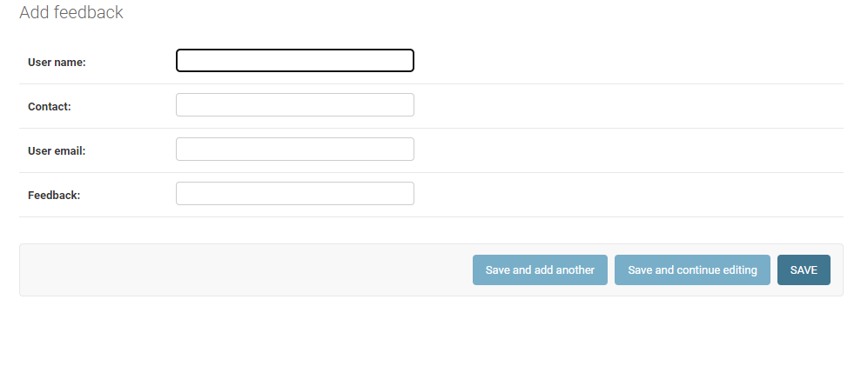

**DATA FLOW DIAGRAM**

**Introduction:**-

DFD is an acronym for the word Data Flow Diagram. DFD is pictorial representation of the system. DFD is a graphical representation of the flow of data through the information system. DFD are also used for the visualization of data processing (structured design). A DFD provides no information about the timings of the process, or about whether process will operate in parallel or sequence. It is an important technique for modeling a system’s high-level detail by showing how input data is transformed to output results through sequence of functional transformations. DFD reveal relationships among between the various components in a program or system. The strength of DFD lies in the fact that using few symbols we are able to express program design in an easier manner. A DFD can be used to represent the

following:-

Process that change the data.

Data Storage locations.

In the DFD, four symbols are used and they are as follows:

1. A square defines a External Entity sending and receiving data.

2) An arrow defines Flow of data within the system. It is a pipeline through which

information flows.

3) An open rectangle is a data store, data at rest, or a temporary repository of data

1. A circle represents a process that transfers informing data flows into outgoing data flows.

**Uses of DFD:-**

The main uses of data flow diagrams are as follows:-

* DFD is a method of choice for representation of showing of information through a system because of the following reasons:-
* DFDs are easier to understand by technical and non-technical audiences.
* DFDs can provide high level system overview, complete with boundaries and connections to other system.
* DFDs can provide a detailed representation of system components.

**Context Diagram**

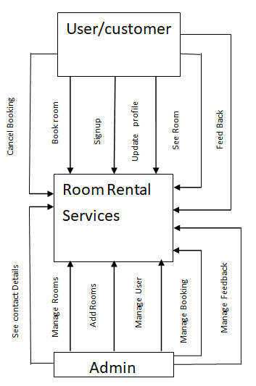

**Level 1 DFD**

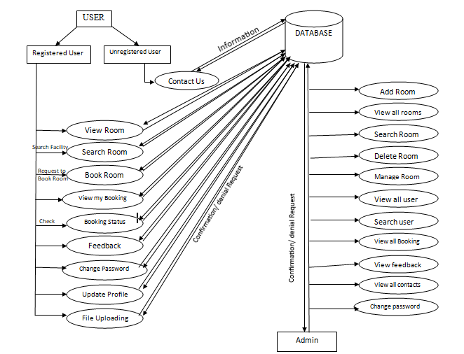

**ER-Diagram**

**Introduction:-**

In [software engineering, an entity](http://en.wikipedia.org/wiki/Software_engineering)-relationship model (ERM) is an abstract and conceptual representation of [data.](http://en.wikipedia.org/wiki/Data) Entity-relationship modeling is a [database](http://en.wikipedia.org/wiki/Database_model) [modeling method,](http://en.wikipedia.org/wiki/Database_model) used to produce a type of [conceptual](http://en.wikipedia.org/wiki/Conceptual_schema) [semantic data](http://en.wikipedia.org/wiki/Semantic_data_model) [model of a](http://en.wikipedia.org/wiki/Semantic_data_model) system, often a [relational database, and](http://en.wikipedia.org/wiki/Relational_database) its requirements [in a top-down](http://en.wikipedia.org/wiki/Top-down) [fashion.](http://en.wikipedia.org/wiki/Top-down) Diagrams created by this process are called entity-relationship diagrams, ER diagrams, or ERDs. ER Diagrams depicts relationship between data objects. The attribute of each data objects noted in the entity-relationship diagram can be described using a data object description. Entity relationship diagram is very basic, conceptual model of data and it is fundamental to the physical database design. This analysis is then used to organize data as relations, normalizing relations, and obtaining a Relational database.

The entity-relationship model for data uses three features to describe data. These are:

1. Entities which specify distinct real-world items in an application.
2. Relationship, which connect entities and represent meaningful dependencies between them.
3. Attributes which specify properties of entities & relationships.

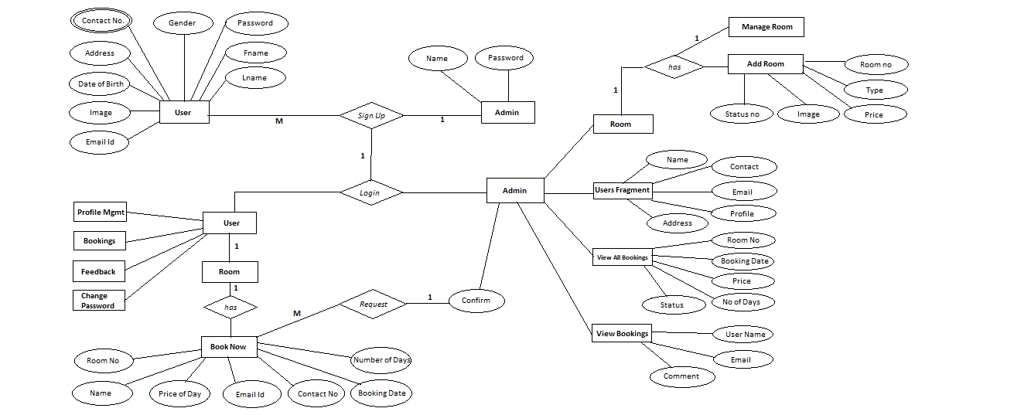

1. **IMPLEMENTATION**

Implementation is the stage of the project when the theoretical design is turned out into a working system. Thus, it can be considered to be the most critical stage in achieving a successful new system and it giving the user, confidence that the new system will work and be effective.

**CODING and TESTING:**

First create project by given command into Command prompt.

C:\django>django-admin startproject room rental services

From command prompt change directory

C:\django>cd room rental services

This will create a room rental services directory with the following contents:

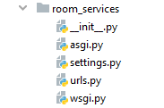

**Installed App in settings.py:-**

*# Application definition*INSTALLED_APPS = [  
 **'django.contrib.admin'**,  
 **'django.contrib.auth'**,  
 **'django.contrib.contenttypes'**,  
 **'django.contrib.sessions'**,  
 **'django.contrib.messages'**,  
 **'django.contrib.staticfiles'**,  
 **'room'**,  
]

MIDDLEWARE = [  
 **'django.middleware.security.SecurityMiddleware'**,  
 **'django.contrib.sessions.middleware.SessionMiddleware'**,  
 **'django.middleware.common.CommonMiddleware'**,  
 **'django.middleware.csrf.CsrfViewMiddleware'**,  
 **'django.contrib.auth.middleware.AuthenticationMiddleware'**,  
 **'django.contrib.messages.middleware.MessageMiddleware'**,  
 **'django.middleware.clickjacking.XFrameOptionsMiddleware'**,  
]  
  
ROOT_URLCONF = **'room_services.urls'**

**And then create templates folder into the project and to configure the Django template system, go to the settings.py file and update the DIRS to the path of the templates folder. Generally the templates folder is created to store all the template files that are to be used in the project.**

TEMPLATES = [  
 {  
 **'BACKEND'**: **'django.template.backends.django.DjangoTemplates'**,  
 **'DIRS'**: [],  
 **'APP_DIRS'**: **True**,  
 **'OPTIONS'**: {  
 **'context_processors'**: [  
 **'django.template.context_processors.debug'**,  
 **'django.template.context_processors.request'**,  
 **'django.contrib.auth.context_processors.auth'**,  
 **'django.contrib.messages.context_processors.messages'**,  
 ],  
 },  
 },  
]  
  
WSGI_APPLICATION = **'room_services.wsgi.application'***# Database  
# https://docs.djangoproject.com/en/4.0/ref/settings/#databases*DATABASES = {  
 **'default'**: {  
 **'ENGINE'**: **'django.db.backends.sqlite3'**,  
 **'NAME'**: BASE_DIR / **'db.sqlite3'**,  
 }  
}  
  
  
*# Password validation  
# https://docs.djangoproject.com/en/4.0/ref/settings/#auth-password-validators*AUTH_PASSWORD_VALIDATORS = [  
 {  
 **'NAME'**: **'django.contrib.auth.password_validation.UserAttributeSimilarityValidator'**,  
 },  
 {  
 **'NAME'**: **'django.contrib.auth.password_validation.MinimumLengthValidator'**,  
 },  
 {  
 **'NAME'**: **'django.contrib.auth.password_validation.CommonPasswordValidator'**,  
 },  
 {  
 **'NAME'**: **'django.contrib.auth.password_validation.NumericPasswordValidator'**,  
 },  
]  
  
  
*# Internationalization  
# https://docs.djangoproject.com/en/4.0/topics/i18n/*LANGUAGE_CODE = **'en-us'**TIME_ZONE = **'UTC'**USE_I18N = **True**USE_TZ = **True***# Static files (CSS, JavaScript, Images)  
# https://docs.djangoproject.com/en/4.0/howto/static-files/*STATIC_URL = **'static/'***# Default primary key field type  
# https://docs.djangoproject.com/en/4.0/ref/settings/#default-auto-field*DEFAULT_AUTO_FIELD = **'django.db.models.BigAutoField'**

**import** os  
  
STATIC_URL = **'/static/'**MEDIA_URL = **'/media/'**MEDIA_ROOT = os.path.join(BASE_DIR,**'media'**)

**Models.py to create the tables**

**from** django.db **import** models  
**from** django.contrib.auth.models **import** User  
  
**class** Signup(models.Model):  
 user=models.ForeignKey(User,on_delete=models.CASCADE)  
 mobile = models.CharField(max_length=20,null=**True**)  
 gender = models.CharField(max_length=20,null=**True**)  
 image = models.FileField(null=**True**)  
 dob = models.CharField(max_length=10,null=**True**)  
 address = models.CharField(max_length=50,null=**True**)  
 **def** _str_(self):  
 **return** self.user.username  
  
**class** Room(models.Model):  
 room_no = models.IntegerField(max_length=20,null=**True**)  
 price = models.CharField(max_length=20,null=**True**)  
 type = models.CharField(max_length=20,null=**True**)  
 image = models.FileField(max_length=20,null=**True**)  
 status = models.CharField(max_length=20,null=**True**)  
  
**class** Booking(models.Model):  
 room_no=models.CharField(max_length=20,null=**True**)  
 user_name=models.CharField(max_length=30,null=**True**)  
 user_email=models.CharField(max_length=30,null=**True**)  
 contact1=models.CharField(max_length=30,null=**True**)  
 contact2=models.CharField(max_length=30,null=**True**)  
 booking_date=models.CharField(max_length=30,null=**True**)  
 days=models.CharField(max_length=20,null=**True**)  
 gender=models.CharField(max_length=20,null=**True**)  
 price=models.CharField(max_length=20,null=**True**)  
 dob=models.CharField(max_length=20,null=**True**)  
 status=models.CharField(max_length=20,null=**True**)  
  
**class** Contact(models.Model):  
 name=models.CharField(max_length=30,null=**True**)  
 contact=models.CharField(max_length=30,null=**True**)  
 email=models.CharField(max_length=30,null=**True**)  
 purpose=models.CharField(max_length=50,null=**True**)  
  
**class** Feedback(models.Model):  
 user_name=models.CharField(max_length=20,null=**True**)  
 contact=models.CharField(max_length=30,null=**True**)  
 user_email=models.CharField(max_length=30,null=**True**)  
 feedback=models.CharField(max_length=250,null=**True**)

**Admin.py to register all the tables in the database**

**from** django.contrib **import** admin  
**from** .models **import** *  
  
admin.site.register(Signup)  
admin.site.register(Room)  
admin.site.register(Booking)  
admin.site.register(Contact)  
admin.site.register(Feedback)

**Views.py to define the functions**

**from** django.shortcuts **import** render,redirect  
**from** django.contrib.auth.models **import** User,auth  
**from** django.contrib.auth **import** authenticate,login,logout  
**from** .models **import** *  
**from** django.db.models **import** Q  
  
**def** index(request):  
 **return** render(request,**'index.html'**)  
  
**def** login(request):  
 error=**""  
 if** request.method==**'POST'**:  
 u = request.POST[**'uname'**]  
 p = request.POST[**'pwd'**]  
 user = auth.authenticate(username=u,password=p)  
 **try**:  
 **if** user.is_staff:  
 auth.login(request, user)  
 error = **"no"  
 elif** user **is not None**:  
 auth.login(request, user)  
 error = **"not"  
 else**:  
 error = **"yes"  
 except**:  
 error = **"yes"** d = {**'error'**: error}  
 **return** render(request, **'login.html'**, d)  
  
**def** contact(request):  
 **return** render(request,**'contact.html'**)  
  
**def** signup(request):  
 error=**""  
 if** request.method==**'POST'**:  
 f = request.POST[**'fname'**]  
 l = request.POST[**'lname'**]  
 e = request.POST[**'email'**]  
 c = request.POST[**'contact'**]  
 dob = request.POST[**'dob'**]  
 p = request.POST[**'pwd'**]  
 gen = request.POST[**'gender'**]  
 i = request.FILES[**'image'**]  
 a = request.POST[**'address'**]  
 **try**:  
 user = User.objects.create_user(first_name=f,last_name=l,username=e,password=p)  
 Signup.objects.create(user=user,mobile=c,gender=gen,image=i,dob=dob,address=a)  
 error=**"no"  
 except**:  
 error=**"yes"** d = {**'error'**:error}  
 **return** render(request,**'signup.html'**,d)  
  
**def** admin_home(request):  
 **return** render(request,**'admin_home.html'**)  
  
  
**def** user_home(request):  
 user=request.user  
 data=Signup.objects.get(user=user)  
 d={**'data'**:data}  
 **return** render(request,**'user_home.html'**,d)  
  
**def** view_user(request):  
 **if 'q' in** request.GET:  
 q=request.GET[**'q'**]  
 data=Signup.objects.filter(mobile__icontains=q)  
 *# multipleq=Q(Q()Q(mobile__icontains=q)|Q(gender__icontains=q))* **else**:  
 data = Signup.objects.all()  
 d = {**'data'**:data}  
 **return** render(request,**'view_user.html'**,d)  
  
  
**def** view_room_admin(request):  
 **if 'q' in** request.GET:  
 q=request.GET[**'q'**]  
 multipleq=Q(Q(room_no__icontains=q)|Q(price__icontains=q)|Q(status__icontains=q)|Q(type__icontains=q))  
 data=Room.objects.filter(multipleq)  
 **else**:  
 data = Room.objects.all()  
 d = {**'data'**:data}  
 **return** render(request,**'view_room_admin.html'**,d)  
  
**def** add_room(request):  
 error=**""  
 if** request.method==**'POST'**:  
 r = request.POST[**'roomno'**]  
 p = request.POST[**'price'**]  
 t = request.POST[**'rtype'**]  
 s = request.POST[**'status'**]  
 i = request.FILES[**'image'**]  
 **try**:  
 Room.objects.create(room_no=r,price=p,type=t,image=i,status=s)  
 *#it is like imsert into commnd in sql* error=**"no"  
 except**:  
 error=**"yes"** d = {**'error'**:error}  
 **return** render(request,**'add_room.html'**,d)  
  
**def** delete_room(request,id):  
 data = Room.objects.get(id=id)  
 data.delete()  
 **return** redirect(**'view_room_admin'**)  
  
**def** edit_room(request ,id):  
 error=**""  
 if not** request.user.is_authenticated:  
 **return** redirect(**'login'**)  
 data=Room.objects.get(id=id)  
 **if** request.method == **"POST"**:  
 r=request.POST[**"roomno"**]  
 p=request.POST[**"price"**]  
 t=request.POST[**"rtype"**]  
 s=request.POST[**"status"**]  
 data.room_no=r  
 data.price=p  
 data.type=t  
 data.status=s  
 **try**:  
 i=request.FILES[**'room_img'**]  
 data.image=i  
 **except**:  
 **pass  
 try**:  
 data.save()  
 error=**"no"  
 except**:  
 error=**"yes"** d={**'data'**:data,**'error'**:error}  
 **return** render(request,**'edit_room.html'**,d)  
  
  
**def** delete_user(request ,id):  
 data=User.objects.get(id=id)  
 data.delete()  
 **return** redirect(**'view_user'**)  
  
**def** Logout(request):  
 logout(request)  
 **return** redirect(**'login'**)  
  
**def** view_room_user(request):  
 **if not** request.user.is_authenticated:  
 **return** redirect(**'login'**)  
 error=**""  
 if 'q' in** request.GET:  
 q=request.GET[**'q'**]  
 multipleq=Q(Q(room_no__icontains=q)|Q(price__icontains=q)|Q(status__icontains=q)|Q(type__icontains=q))  
 data=Room.objects.filter(multipleq)  
 **else**:  
 data=Room.objects.all()  
 d={**'data'**:data}  
 **return** render(request,**'view_room_user.html'**,d)  
  
**def** my_booking(request):  
 data=Booking.objects.all()  
 d={**'data'**:data}  
 **return** render(request,**'my_booking.html'**,d)  
  
**def** book_room(request,id):  
 user=request.user *#to get current user that has signed up* data=Room.objects.get(id=id)  
 data2=Signup.objects.get(user=user)  
 error=**""  
 if** request.method == **"POST"**:  
 f=request.POST[**'fname'**]  
 l=request.POST[**'lname'**]  
 fl=f+**" "**+l  
 e=request.POST[**'email'**]  
 r=request.POST[**'room_no'**]  
 c1=request.POST[**'contact'**]  
 c2=request.POST[**'contact2'**]  
 bd=request.POST[**'booking_date'**]  
 d=request.POST[**'select_days'**]  
 g=request.POST[**'gender'**]  
 p=request.POST[**'price'**]  
 dob=request.POST[**'dob'**]  
 **try**:  
 Booking.objects.create(room_no=r,user_name=fl,user_email=e,contact1=c1,contact2=c2,booking_date=bd,days=d,gender=g,price=p,dob=dob,status=**"pending"**)  
 error=**"no"  
 except**:  
 error=**"yes"** d={**'data'**:data,**'data2'**:data2,**'error'**:error}  
 **return** render(request,**'book_room.html'**,d)  
  
**def** cancel_booking(request,id):  
 data=Booking.objects.get(id=id)  
 data.delete()  
 **return** redirect(**'my_booking'**)  
  
**def** cancel_booking_admin(request,id):  
 data=Booking.objects.get(id=id)  
 data.delete()  
 **return** redirect(**'view_booking_admin'**)  
  
**def** change_password(request):  
 **return** render(request,**'change_password.html'**)  
  
**def** change_password_user(request):  
 error=**""  
 if** request.method == **'POST'**:  
 c=request.POST[**'currentpassword'**]  
 n=request.POST[**'newpassword'**]  
 **try**:  
 u=User.objects.get(id=request.user.id)  
 **if** u.check_password(c):  
 u.set_password(n)  
 u.save()  
 error=**"no"  
 else**:  
 error=**"not"  
 except**:  
 error=**"yes"** d={**'error'**:error}  
 **return** render(request,**'change_password.html'**,d)  
  
**def** change_password_admin(request):  
 error=**""  
 if** request.method == **'POST'**:  
 c=request.POST[**'currentpassword'**]  
 n=request.POST[**'newpassword'**]  
 **try**:  
 u=User.objects.get(id=request.user.id)  
 **if** u.check_password(c):  
 u.set_password(n)  
 u.save()  
 error=**"no"  
 else**:  
 error=**"not"  
 except**:  
 error=**"yes"** d={**'error'**:error}  
 **return** render(request,**'change_password_admin.html'**,d)  
  
**def** view_booking_admin(request):  
 data=Booking.objects.all()  
 d={**'data'**:data}  
 **return** render(request,**'view_booking_admin.html'**,d)  
  
**def** feedback(request):  
 error=**""  
 if** request.method == **'POST'**:  
 fname=request.POST[**'fname'**]  
 fphone=request.POST[**'fphone'**]  
 femail=request.POST[**'femail'**]  
 ftext=request.POST[**'feedback'**]  
 **try**:  
 Feedback.objects.create(user_name=fname,contact=fphone,user_email=femail,feedback=ftext)  
 error=**"no"  
 except**:  
 error=**"yes"** d={**'error'**:error}  
 **return** render(request,**'feedback.html'**,d)  
  
**def** contact(request):  
 error=**""  
 if** request.method == **'POST'**:  
 cname=request.POST[**'cname'**]  
 cemail=request.POST[**'cemail'**]  
 cphone=request.POST[**'cphone'**]  
 cpurpose=request.POST[**'cpurpose'**]  
 **try**:  
 Contact.objects.create(name=cname,contact=cphone,email=cemail,purpose=cpurpose)  
 error=**"no"  
 except**:  
 error=**"yes"** d={**'error'**:error}  
 **return** render(request,**'contact.html'**,d)  
  
**def** view_user_feedback(request):  
 data=Feedback.objects.all()  
 data2=Contact.objects.all()  
 d={**'data'**:data,**'data2'**:data2}  
 **return** render(request,**'view_user_feedback.html'**,d)  
  
**def** delete_feedback(request,id):  
 data=Feedback.objects.get(id=id)  
 data.delete()  
 **return** redirect(**'view_user_feedback'**)  
  
**def** delete_contact(request,id):  
 data=Contact.objects.get(id=id)  
 data.delete()  
 **return** redirect(**'view_user_feedback'**)  
  
**def** change_status(request,id):  
 data=Booking.objects.get(id=id)  
 error=**""  
 if** request.method==**'POST'**:  
 s=request.POST[**'rstatus'**]  
 **try**:  
 data.status=s  
 data.save()  
 error=**"no"  
 except**:  
 error=**"yes"** d={**'data'**:data,**'error'**:error}  
 **return** render(request,**'change_status.html'**,d)  
  
**def** edit_user(request):  
 user=request.user  
 data=Signup.objects.get(user=user)  
 **if** request.method == **'POST'**:  
 f=request.POST[**'fname'**]  
 l=request.POST[**'lname'**]  
 e=request.POST[**'email'**]  
 c=request.POST[**'contact'**]  
 g=request.POST[**'gender'**]  
 f=request.POST[**'fname'**]  
 dob=request.POST[**'dob'**]  
 user.first_name=f  
 user.last_name=l  
 data.mobile=c  
 data.gender=g  
 data.dob=dob  
 **try**:  
 i=request.FILES[**'image'**]  
 data.image=i  
 data.save()  
 **except**:  
 **pass  
 try**:  
 user.save()  
 data.save()  
 error=**"no"  
 except**:  
 error=**"yes"** d={**'data'**:data}  
 **return** render(request,**'edit_user.html'**,d)

**urls.py to declare all the urls for the linking of the templates to each other**

**from** django.contrib **import** admin  
**from** django.urls **import** path  
**from** room.views **import** *  
**from** django.conf **import** settings  
**from** django.conf.urls.static **import** static  
  
urlpatterns = [  
 path(**'admin/'**, admin.site.urls),  
 path(**''**,index,name=**'index'**),  
 path(**'login'**,login,name=**'login'**),  
 path(**'contact'**,contact,name=**'contact'**),  
 path(**'signup'**,signup,name=**'signup'**),  
 path(**'admin_home'**,admin_home,name=**'admin_home'**),  
 path(**'user_home'**,user_home,name=**'user_home'**),  
 path(**'view_user'**,view_user,name=**'view_user'**),  
 path(**'view_room_admin'**,view_room_admin,name=**'view_room_admin'**),  
 path(**'add_room'**,add_room,name=**'add_room'**),  
 path(**'delete_room/<int:id>'**,delete_room,name=**'delete_room'**),  
 path(**'edit_room/<int:id>'**,edit_room,name=**'edit_room'**),  
 path(**'delete_user/<int:id>'**,delete_user,name=**'delete_user'**),  
 path(**'Logout'**,Logout,name=**'Logout'**),  
 path(**'view_room_user'**,view_room_user,name=**'view_room_user'**),  
 path(**'my_booking'**,my_booking,name=**'my_booking'**),  
 path(**'book_room/<int:id>'**,book_room,name=**'book_room'**),  
 path(**'cancel_booking/<int:id>'**,cancel_booking,name=**'cancel_booking'**),  
 path(**'cancel_booking_admin/<int:id>'**,cancel_booking_admin,name=**'cancel_booking_admin'**),  
 path(**'change_password'**,change_password,name=**'change_password'**),  
 path(**'change_password_admin'**,change_password_admin,name=**'change_password_admin'**),  
 path(**'view_booking_admin'**,view_booking_admin,name=**'view_booking_admin'**),  
 path(**'feedback'**,feedback,name=**'feedback'**),  
 path(**'contact'**,contact,name=**'contact'**),  
 path(**'view_user_feedback'**,view_user_feedback,name=**'view_user_feedback'**),  
 path(**'delete_feedback/<int:id>'**,delete_feedback,name=**'delete_feedback'**),  
 path(**'delete_contact/<int:id>'**,delete_contact,name=**'delete_contact'**),  
 path(**'change_status/<int:id>'**,change_status,name=**'change_status'**),  
 path(**'edit_user'**,edit_user,name=**'edit_user'**),  
]+static(settings.MEDIA_URL,document_root=settings.MEDIA_ROOT)

**Template files**

1. **Navigation.html**

<!DOCTYPE **html**>  
<**html**>  
<**head**>  
 {% load static %}  
 <**title**></**title**>  
<**link rel="stylesheet" href="https://pro.fontawesome.com/releases/v5.10.0/css/all.css" integrity="sha384-AYmEC3Yw5cVb3ZcuHtOA93w35dYTsvhLPVnYs9eStHfGJvOvKxVfELGroGkvsg+p" crossorigin="anonymous"**/>  
<**link rel="stylesheet" href="https://cdn.jsdelivr.net/npm/bootstrap@5.1.3/dist/css/bootstrap.min.css" integrity="sha384-1BmE4kWBq78iYhFldvKuhfTAU6auU8tT94WrHftjDbrCEXSU1oBoqyl2QvZ6jIW3" crossorigin="anonymous"**/>  
 <**link rel="stylesheet" href="https://cdnjs.cloudflare.com/ajax/libs/animate.css/4.1.1/animate.min.css"**/>  
  
 <**link href="https://cdn.jsdelivr.net/npm/bootstrap@5.2.0-beta1/dist/css/bootstrap.min.css" rel="stylesheet" integrity="sha384-0evHe/X+R7YkIZDRvuzKMRqM+OrBnVFBL6DOitfPri4tjfHxaWutUpFmBp4vmVor" crossorigin="anonymous"**>  
 <**script src="https://cdn.jsdelivr.net/npm/bootstrap@5.2.0-beta1/dist/js/bootstrap.bundle.min.js" integrity="sha384-pprn3073KE6tl6bjs2QrFaJGz5/SUsLqktiwsUTF55Jfv3qYSDhgCecCxMW52nD2" crossorigin="anonymous"**></**script**>  
 <**style**>  
 i{  
 padding-right: 7px;  
 }  
 #aa{  
 display: inline-block;  
 margin-top: 10px;  
 border: 3px solid white;  
 padding-right: 14px;  
 border-radius: 15px;  
 }  
 #aaa{  
 text-decoration: none;  
 padding-left: 20px;  
 font-size: 20px;  
 color:white;  
 font-weight: bold;  
 }  
 #aa:hover{  
 box-sizing:border-box;  
 border:3px solid pink;  
 box-shadow: 0px 0px 5px 5px pink;  
  
 }  
  
 .b1{  
font-size:45px;  
font-style:italic;  
animation-name:b11;  
animation-duration:3s;  
animation-iteration-count:infinite;  
display:inline;  
  
}  
@keyframes b11  
{  
0%{color:black}  
10%{color:black}  
30%{color:gold;text-shadow:1px 1px 1px blue;}  
100%{color:black}  
  
}  
.b2{  
font-size:45px;  
font-style:italic;  
animation-name:b22;  
animation-duration:3s;  
animation-iteration-count:infinite;  
display:inline;  
  
}  
@keyframes b22  
{  
0%{color:black}  
30%{color:black}  
50%{color:gold;text-shadow:1px 1px 1px blue;}  
100%{color:black}  
}  
.b3{  
font-size:45px;  
font-style:italic;  
animation-name:b33;  
animation-duration:3s;  
animation-iteration-count:infinite;  
display:inline;  
}  
@keyframes b33  
{  
0%{color:black}  
60%{color:black}  
80%{color:gold;text-shadow:1px 1px 1px blue;}  
100%{color:black}  
}  
.b4{  
font-size:45px;  
font-style:italic;  
animation-name:b44;  
animation-duration:3s;  
animation-iteration-count:infinite;  
display:inline;  
  
}  
@keyframes b44  
{  
0%{color:black}  
60%{color:black}  
90%{color:black}  
100%{color:gold;text-shadow:1px 1px 1px blue;}  
}  
.animate__heartbeat{  
animation-duration: 2s;  
animation-iteration-count:1;  
}  
</**style**>  
</**head**>  
<**body**>  
  
 <**div class="row" style="width:100%;"** >  
 <**div**>  
 <**img src="{% static 'images/bg1.png' %}" height="200px" width="980px;" style="position:absolute;left:320px; opacity:0.1;"**/>  
 </**div**>  
 <**div class="col-3"** ><**img src="{% static '../static/images/1.jpg' %}" style="height:200px;width:320px;"**></**div**>  
 <**div class="col-6" style="margin-top:60px;"** >  
 <**h1 class="b1"**>Room</**h1**>  
 <**h1 class="b2"**>Rental</**h1**>  
 <**h1 class="b3"**>Services</**h1**>  
 <**h1 class="b4"**>Lucknow</**h1**>  
 </**div**>  
 <**div class="col-3" style="margin-top:60px;position:absolute;left:1000px;"**>  
 <**a href="https://web.whatsapp.com" target="_blank"**><**i class="fab fa-whatsapp" style="font-size: 35px;color: green;"**></**i**></**a**>  
 <**a href="https://www.instagram.com" target="_blank"**><**i class="fab fa-instagram" style="font-size: 35px;color: red;"**></**i**></**a**>  
 <**a href="https://www.twitter.com" target="_blank"**><**i class="fab fa-twitter" style="font-size: 35px;color: blue;"**></**i**></**a**>  
 <**a href="https://www.gmail.com" target="_blank"**><**i class="fas fa-envelope" style="font-size: 35px;color: pink;"**></**i**></**a**>  
 </**div**>  
 </**div**>  
  
 <**div class="row" style="background: grey;width:101%"**>  
 <**div class="col-1"**><**h2 class="animate__animated animate__heartBeat" style="animation-iteration-count: infinite;text-align: center;color:white;margin-left:10px;"**>Welcome</**h2**></**div**>  
 <**div class="col-11"**>  
 <**ul style="float:right;"**>  
 <**li id="aa"**><**a href="{% url 'index' %}" id="aaa"**>Home</**a**></**li**>  
 <**li id="aa"**><**a href="#down" id="aaa"**>About Us</**a**></**li**>  
 <**li id="aa"**><**a href="{% url 'contact' %}" id="aaa"**>Contact Us</**a**></**li**>  
 <**li id="aa"**><**a href="{% url 'login' %}" id="aaa"**>Login</**a**></**li**>  
 <**li id="aa"**><**a href="{% url 'signup' %}" id="aaa"**>Register</**a**></**li**>  
 </**ul**>  
 </**div**>  
 </**div**>  
</**div**>  
</**body**>  
</**html**>

1. **Footer.html**

{% load static %}  
<**a name="top"**></**a**>  
<**div class="mt-3" style="background-color: #222222; width:100% ; height:250px"**>  
 <**div class="container-fluid"**>  
 <**div class="row"**>  
 <**div class="col-md-3 mt-3"**>  
 <**h3 class="text-white"**>Contact Information <**i style="color:red"**>|</**i**></**h3**>  
 <**p style="color:white; font-size: 15px"**><**i class="fa fa-map-marker text-danger"**></**i**> Analyze Infotech, Lucknow</**p**>  
 <**p style="color:white; font-size: 15px"**><**i class="fa fa-envelope text-danger"**></**i**> admin@analyzeinfotech.in</**p**>  
 <**p style="color:white; font-size: 15px"**><**i class="fa fa-mobile text-danger"**></**i**> P: 8896762006 /8707082601</**p**>  
 <**p style="color:white; font-size: 15px"**><**i class="fa fa-globe text-danger"**></**i**> W: www.analyzeinfotech.in</**p**>  
 </**div**>  
  
 <**div class="col-md-6 mt-3"**>  
 <**h3 class="text-white"**>About Room Services <**i style="color:red"**>|</**i**></**h3**>  
 <**p style="color:white; font-size:17px"**>Lucknow Room rental services is running since 5years. We are providing room's on perday  
 bases with in normal price. We are trying to provide best services to our customer's using our team and  
 we take care of our customer's. We are providing room in three category like single person, couples and  
 for family at different prices. And we provide fully AC room's, well cleaned room and WiFi service with fast speed  
 24*7 hours.</**p**>  
 </**div**>  
  
 <**div class="col-md-3 mt-3"**>  
 <**h3 class="text-white"**>Current News <**i style="color:red"**>|</**i**></**h3**>  
 <**marquee scrollamount="3" behavior="" direction="up"**>  
 <**p style="color:white; font-size:15px"**>Without mask no entry for enquiry. Due to COVID19 be safe.</**p**>  
 <**form method="post" class="form-inline"**>  
 {% csrf_token %}  
 </**form**>  
 </**marquee**>  
 </**div**>  
 </**div**>  
 </**div**>  
</**div**>  
<**a name="down"**></**a**>

1. **index.html**

<**html**>  
<**head**>  
 {% include 'navigation.html' %}  
 {% load static %}  
  
 <**style**>  
 .abc{  
 height:500px;  
 margin-top:10px;  
 background-size:100% 100%;  
 animation: abcd 20s infinite;  
 transition:ease-in;  
 }  
 @keyframes abcd{  
 0%{background-image:url({% static 'images/1.jpg' %});}  
 20%{background-image:url({% static 'images/2.jpg' %});}  
 40%{background-image:url({% static 'images/3.jpg' %});}  
 60%{background-image:url({% static 'images/4.jpeg' %});}  
 80%{background-image:url({% static 'images/5.jpg' %});}  
 100%{background-image:url({% static 'images/6.jpg' %});}  
 }  
 video {  
 object-fit:fill;  
}  
</**style**>  
  
  
  
</**head**>  
  
<**body**>  
  
<**div class="container-fluid abc"**></**div**>  
  
<**div style=" width:1350px; height:500px;margin-top:10px;"**>  
 <**div style="height:500px;width:100%;float:left"**>  
 <**video autoplay="" muted="" loop="" playsinline="" width="1350" height="500"**>  
 <**source src="{% static 'videos/waves.mp4' %}" type="video/mp4"** />  
 Your browser does not support videos  
 </**video**>  
 </**div**>  
 <**div style="float:left;margin-top:-200px;"**>  
 <**p style="font-size:45px;color:white;font-style:Roboto;margin-left:50px;"**>We, Provide you the best rooms in our apartments<**br**>  
 at pocket friendly prizes</**p**>  
 </**div**>  
</**div**>  
  
{% include 'footer.html' %}  
  
  
</**body**>  
</**html**>  
</**html**>

**4. Contact.html**

<!DOCTYPE **html**>  
<**html lang="en"**>  
<**head**>  
 <**div**>  
 <**img src="/static/images/bg4.png" height="200px" width="77%" style="position:absolute; opacity:0.2;margin-left:310px;"**/>  
 </**div**>  
 {% include 'navigation.html'%}  
 <**meta charset="UTF-8"**>  
 <**title**>Title</**title**>  
</**head**>  
<**body**>  
<**div style="margin:0 auto"** >  
 <**div class="row"**>  
 <**center**><**p style="font-size:30px;color:blue;font-family:italics;"**>Contact Us<**p**></**center**>  
 </**div**>  
 <**p class="text-center w-responsive mx-auto mb-5"**>Do you have any questions? Please do not hesitate to contact us directly. Our team will come back to you within  
 a matter of hours to help you.</**p**>  
 <**div class="container" style="margin-top:50px;"**>  
 <**form method="post" action="" class="container mt-5"**>  
 {% csrf_token %}  
 <**label**>Name</**label**><**br**><**input type="text" name="cname" class="form-control" required="true"**><**br**>  
 <**label**>Email</**label**><**br**><**input type="email" name="cemail" class="form-control" required="true"**><**br**>  
 <**label**>Phone no.</**label**><**br**><**input type="number" name="cphone" class="form-control" required="true"**><**br**>  
 <**label**>Purpose</**label**><**br**><**input type="text" name="cpurpose" class="form-control" required="true"**><**br**>  
 <**center**>  
 <**input type="submit" value="Submit" class="btn btn-primary btn-lg"**>  
 </**center**>  
 </**form**>  
 </**div**>  
 <**div class="col-3"**></**div**>  
</**div**>  
{% include 'footer.html' %}  
  
{% if error == "no" %}  
<**script**>  
alert("Submit Successfully")  
window.location = ('{% url 'contact' %}')  
</**script**>  
{% endif %}  
  
{% if error == "yes" %}  
<**script**>  
alert("Something went wrong!")  
window.location = ('{% url 'contact' %}')  
</**script**>  
{% endif %}  
  
</**body**>  
</**html**>

**5. signup.html**

{% load static %}  
<**div**>  
 <**img src="/static/images/bg1.png" height="200px" width="77%" style="position:absolute; opacity:0.2;margin-left:310px;"**/>  
</**div**>  
{% include 'navigation.html' %}  
  
<**script**>  
 function checkpass()  
 {  
 if(document.signup.pwd.value!=document.signup.cpwd.value)  
 {  
 alert('Password Does Not Match')  
 document.signup.cpwd.focus();  
 return false;  
 }  
 return true;  
 }  
</**script**>  
  
<**marquee style="font-family: 'Monotype Corsiva'; font-size:25px; color:darkcyan; background-color:black; font-weight:bold; margin-top:1%"**>  
 User Signup  
</**marquee**>  
<**hr**>  
<**form class="container mt-5" onsubmit="return checkpass();" name="signup" method="post" enctype="multipart/form-data"**>  
 {% csrf_token %}  
  
 <**div class="row"**>  
 <**div class="form-group col-6"** >  
 <**label**>First Name</**label**>  
 <**input type="text" class="form-control" name="fname" placeholder="Enter First Name" required**>  
 </**div**>  
  
 <**div class="form-group col-6"** >  
 <**label**>Last Name</**label**>  
 <**input type="text" class="form-control" name="lname" placeholder="Enter Last Name"**>  
 </**div**>  
 </**div**>  
  
 <**div class="row"**>  
 <**div class="form-group col-md-12"** >  
 <**label**>Email ID:</**label**>  
 <**input type="text" class="form-control" name="email" placeholder="Enter Email Address" required**>  
 </**div**>  
 </**div**>  
  
 <**div class="row"**>  
 <**div class="form-group col-md-6"** >  
 <**label**>Contact Number:</**label**>  
 <**input type="text" class="form-control" name="contact" placeholder="Enter Phone Number" required**>  
 </**div**>  
 <**div class="form-group col-md-6"** >  
 <**label**>Date of Birth:</**label**>  
 <**input type="date" class="form-control" name="dob" required**>  
 </**div**>  
 </**div**>  
  
 <**div class="row"**>  
 <**div class="form-group col-md-6"** >  
 <**label**>Password:</**label**>  
 <**input type="password" class="form-control" name="pwd" placeholder="Enter Password" required**>  
 </**div**>  
  
 <**div class="form-group col-md-6"** >  
 <**label**>Confirm Password:</**label**>  
 <**input type="password" class="form-control" name="cpwd" placeholder="Confirm Password" required**>  
 </**div**>  
 </**div**>  
  
 <**div class="row"**>  
 <**div class="form-group col-md-6"** >  
 <**label**>Gender</**label**>  
 <**div style="border:1px solid lightgrey ; padding:6px ; border-radius:6px"**>  
 <**div class="custom-control custom-radio custom-control-inline"**>  
 <**input type="radio" id="customRadioInLine1" name="gender" class="custom-control-input" value="Male"**>  
 <**label class="custom-control-label" for="customRadioInLine1"**>Male</**label**>  
 </**div**>  
 <**div class="custom-control custom-radio custom-control-inline"**>  
 <**input type="radio" id="customRadioInLine2" name="gender" class="custom-control-input" value="Female"**>  
 <**label class="custom-control-label" for="customRadioInLine2"**>Female</**label**>  
 </**div**>  
 </**div**>  
 </**div**>  
  
 <**div class="form-group col-md-6"** >  
 <**label**>Image</**label**>  
 <**input type="file" class="form-control" name="image" required**>  
 </**div**>  
 <**div class="form-group col-md-12"** >  
 <**label**>Address:</**label**>  
 <**input type="text" class="form-control" name="address" placeholder="Enter Your Address" required**>  
 </**div**>  
 </**div**>  
<**input type="submit" value="Submit" class="btn btn-primary my-3" style="width:200px"**>  
</**form**>  
{% include 'footer.html' %}  
{% if error == "no" %}  
<**script**>  
 alert("Signup Successfully")  
 window.location = ('{% url 'signup' %}')  
</**script**>  
{% endif %}  
  
{% if error == "yes" %}  
<**script**>  
 alert("Something Wrong, Try Again...")  
</**script**>  
{% endif %}

**6. login.html**

<!DOCTYPE **html**>  
<**html lang="en"**>  
<**head**>  
 <**div**>  
 <**img src="/static/images/bg4.png" height="200px" width="77%" style="position:absolute; opacity:0.2;margin-left:310px;"**/>  
 </**div**>  
 {% include 'navigation.html' %}  
 {% load static %}  
 <**meta charset="UTF-8"**>  
 <**title**>Title</**title**>  
</**head**>  
<**body**>  
<**form action="" method="post"**>  
 {% csrf_token %}  
<**div class="container" style="margin-top:100px;"**>  
 <**div class="row"**>  
 <**div class="col-3"**></**div**>  
 <**div class="col-6"**>  
 <**label**>Username:</**label**> <**input type="text" name="uname" class="form-control"**>  
 <**label**>Password:</**label**> <**input type="password" name="pwd" class="form-control"**> <**br**>  
 <**center**>  
 <**a href="" class="btn btn-secondary btn-lg"**>Cancel</**a**> |  
 <**input type="submit" value="Login" class="btn btn-primary btn-lg"**>  
 </**center**>  
 <**div class="col-3"**></**div**>  
 </**div**>  
 <**div class="col-2"**></**div**>  
 </**div**>  
</**div**>  
</**form**>  
<**br**><**br**><**br**>  
{% include 'footer.html' %}  
</**body**>  
</**html**>  
  
{% if error == "no" %}  
<**script**>  
 alert("Admin Login Successfully")  
 window.location = ('{% url 'admin_home' %}')  
</**script**>  
{% endif %}  
  
{% if error == "not" %}  
<**script**>  
 alert("User Login Successfully")  
 window.location = ('{% url 'user_home' %}')  
</**script**>  
{% endif %}  
  
{% if error == "yes" %}  
<**script**>  
 alert("Something Wrong, Try Again...")  
</**script**>  
{% endif %}

**7.usernavigation.html**

<!DOCTYPE **html**>  
<**div**>  
 <**img src="/static/images/bg1.png" height="200px" width="100%" style="position:absolute; opacity:0.1"**/>  
</**div**>  
<**html**>  
<**head**>  
 {% load static %}  
 <**title**></**title**>  
 <**link rel="stylesheet" href="https://pro.fontawesome.com/releases/v5.10.0/css/all.css" integrity="sha384-AYmEC3Yw5cVb3ZcuHtOA93w35dYTsvhLPVnYs9eStHfGJvOvKxVfELGroGkvsg+p" crossorigin="anonymous"**/>  
 <**link rel="stylesheet" href="https://cdn.jsdelivr.net/npm/bootstrap@5.1.3/dist/css/bootstrap.min.css" integrity="sha384-1BmE4kWBq78iYhFldvKuhfTAU6auU8tT94WrHftjDbrCEXSU1oBoqyl2QvZ6jIW3" crossorigin="anonymous"**>  
 <**link rel="stylesheet" href="https://cdnjs.cloudflare.com/ajax/libs/font-awesome/6.0.0/css/all.min.css" integrity="sha512-9usAa10IRO0HhonpyAIVpjrylPvoDwiPUiKdWk5t3PyolY1cOd4DSE0Ga+ri4AuTroPR5aQvXU9xC6qOPnzFeg==" crossorigin="anonymous" referrerpolicy="no-referrer"** />  
 <**link rel="stylesheet" href="https://cdnjs.cloudflare.com/ajax/libs/font-awesome/6.0.0/css/all.min.css" integrity="sha512-9usAa10IRO0HhonpyAIVpjrylPvoDwiPUiKdWk5t3PyolY1cOd4DSE0Ga+ri4AuTroPR5aQvXU9xC6qOPnzFeg==" crossorigin="anonymous" referrerpolicy="no-referrer"** />  
 <**link rel="stylesheet" href="https://cdnjs.cloudflare.com/ajax/libs/font-awesome/6.0.0/css/brands.min.css" integrity="sha512-bSncow0ApIhONbz+pNI52n0trz5fMWbgteHsonaPk42JbunIeM9ee+zTYAUP1eLPky5wP0XZ7MSLAPxKkwnlzw==" crossorigin="anonymous" referrerpolicy="no-referrer"** />  
 <**style**>  
 i{  
 padding-right: 7px;  
 }  
 #aa{  
 display: inline-block;  
 margin-top: 10px;  
 border: 3px solid cyan;  
 padding-right: 14px;  
 border-radius: 15px;  
 }  
 #aa:haver{  
 background:yellow;  
 }  
 #aaa{  
 text-decoration: none;  
 padding-left: 20px;  
 font-size: 20px;  
 font-weight: bold;  
 }  
 #aa:hover{  
 box-shadow: 0px 0px 7px 7px white;  
 }  
</**style**>  
</**head**>  
<**body**>  
<**div**>  
 <**div class="row"**>  
 <**div class="col-3"**><**img src="{% static 'images/2.jpg' %}" height="200" style="width: 100%;"**></**div**>  
 <**div class="col-7"**><**h1 style="color: red;margin-top: 60px;font-size: 45px;"**>Room Rental Services Lucknow</**h1**></**div**>  
 <**div class="col-2" style="margin-top: 60px;"**>  
 <**i class="fab fa-whatsapp" style="font-size: 35px;color: green;"**></**i**>  
 <**i class="fab fa-instagram" style="font-size: 35px;color: red;"**></**i**>  
 <**i class="fab fa-twitter" style="font-size: 35px;color: blue;"**></**i**>  
 <**i class="fas fa-envelope" style="font-size: 35px;color: pink;"**></**i**>  
 </**div**>  
 </**div**>  
 <**div class="row" style="background: lightgreen;width:101%"**>  
 *<!--<div class="col-1"><h2>Welcome<a href="{% url 'edit_user' %}" style="float:left"><i class="fa-solid fa-user-tie" style="float:left"></i></a></h2></div>-->* <**div class="col-1"**><**h2**>Welcome</**h2**></**div**>  
 <**div class="col-11"**>  
 <**ul style="float: right;"**>  
 <**li id="aa"**><**a href="{% url 'user_home' %}" id="aaa"**>Home</**a**></**li**>  
 <**li id="aa"**><**a href="{% url 'view_room_user' %}" id="aaa"**>Room</**a**></**li**>  
 <**li id="aa"**><**a href="{% url 'my_booking' %}" id="aaa"**>Booking's</**a**></**li**>  
 <**li id="aa"**><**a href="{% url 'feedback' %}" id="aaa"**>Feedback</**a**></**li**>  
 <**li id="aa"**><**a href="{% url 'change_password' %}" id="aaa"**>Change Password</**a**></**li**>  
 <**li id="aa"**><**a href="{% url 'Logout' %}" id="aaa"**>Logout</**a**></**li**>  
 </**ul**>  
 </**div**>  
 </**div**>  
</**div**>  
</**body**>  
</**html**>

**8. userhome.html**

<!DOCTYPE **html**>  
<**html lang="en"**>  
<**head**>  
 {% include 'user_navigation.html' %}  
 <**meta charset="UTF-8"**>  
 <**title**>Title</**title**>  
 {% load static %}  
  
 <**style**>  
 .abc{  
 height:500px;  
 margin-top:10px;  
 background-image:url({% static 'images/7.jpg' %});  
 background-size:100% 100%;  
 animation: abcd 20s infinite;  
 transition:ease-in;  
 }  
 @keyframes abcd{  
 0%{background-image:url({% static 'images/1.jpg' %});}  
 20%{background-image:url({% static 'images/2.jpg' %});}  
 40%{background-image:url({% static 'images/3.jpg' %});}  
 60%{background-image:url({% static 'images/4.jpeg' %});}  
 80%{background-image:url({% static 'images/5.jpg' %});}  
 100%{background-image:url({% static 'images/6.jpg' %});}  
 }  
</**style**>  
  
</**head**>  
<**body**>  
<**div class="row"**>  
 <**div class="col-6" style="margin-top:30px;font-family:Monotype Corsiva"**><**h4 style="color:black;"**>{{data.user}}</**h4**></**div**>  
 <**div class="col-6" style="margin-top:-10px;"**><**a href="{% url 'edit_user' %}"**><**img src="{{data.image.url}}" style="border:1px solid white; width:100px; height:100px ; border-radius:50%"**></**a**></**div**>  
</**div**>  
*<!--<div style="margin-top:-60px;margin-left:670px;">-->  
<!-- -->  
<!--</div>-->*<**div class="container-fluid abc"**></**div**>  
{% include 'footer.html' %}  
</**body**>  
</**html**>

**9. view_room_user.html**

<!DOCTYPE **html**>  
<**html lang="en"**>  
<**head**>  
 <**meta charset="UTF-8"**>  
 <**title**>Title</**title**>  
 {% include 'user_navigation.html' %}  
</**head**>  
<**body**>  
<**div style="height:50px; width:300px;float:right;margin:20px 50px 0px 0px;box-shadow:border-box;" class="btn btn-primary"**>  
 <**form class="navbar-form navbar-left" action="{% url 'view_room_user'%}"**>  
 <**div class="input-group"**>  
 <**input type="search" name="q" class="form-control" placeholder="Search Room No / Type / Price"**>  
 <**div class="input-group-btn" style="margin-left:-50px;"**>  
 <**button class="btn btn-default" type="submit"**>  
 <**i class="fa fa-search" aria-hidden="true"**></**i**>  
 </**button**>  
 </**div**>  
 </**div**>  
 </**form**>  
</**div**>  
<**div class="container"**>  
  
 <**div class="row"**>  
 {% if data %}  
 {% for i in data %}  
 <**div class="card float col-3 mt-3 mb-2 " style="width:400px"**>  
 <**h3**><**font face="mv boli" size="5"**>Room Number: {{i.room_no}}</**font**></**h3**>  
 <**img class="card-img-top" src="{{i.image.url}}" alt="Card image" height="200px"**>  
 <**div class="card-body"**>  
 <**h4 class="card-title"**>{{i.type}}</**h4**>  
 <**h5 class="card-title"**>Price: {{i.price}} /Day</**h5**>  
 <**div class="form-row"**>  
 <**div class="form-group col-md-6"** >  
 <**p class="card-text"**>{{i.status}}</**p**>  
 </**div**>  
  
 <**div class="form-group col-10"** >  
 {% if i.status == 'Available' %}  
 <**a href="{% url 'book_room' i.id %}" class="btn btn-primary"**>Book Now</**a**>  
 {% endif %}  
 </**div**>  
  
 </**div**>  
 </**div**>  
 </**div**>  
  
 {% endfor %}  
 {% else %}  
 <**center**><**h3**>No Data Found:</**h3**></**center**>  
 {% endif %}  
 </**div**>  
  
</**div**>  
  
  
</**body**>  
</**html**>

**10. book_room.html**

{% include 'user_navigation.html' %}  
  
<**script**>  
 function room_price()  
 {  
 a=document.signup.select_days.value  
 b=document.signup.price.value  
 c=a*b  
 alert('Final price is '+c)  
 return true;  
 }  
</**script**>  
  
  
<**marquee style="font-family: 'Monotype Corsiva'; font-size:25px; color:darkcyan; background-color:black; font-weight:bold; margin-top:1%"**>  
 Confirm Room Booking  
</**marquee**>  
<**hr**>  
<**form class="container mt-5" onsubmit="return room_price();" name="signup" method="post" enctype="multipart/form-data"**>  
 {% csrf_token %}  
  
 <**div class="row"**>  
 <**div class="form-group col-md-6"** >  
 <**label**>First Name</**label**>  
 <**input type="text" class="form-control" name="fname" value="{{user.first_name}}"** >  
 </**div**>  
  
 <**div class="form-group col-md-6"** >  
 <**label**>Last Name</**label**>  
 <**input type="text" class="form-control" name="lname" value="{{user.last_name}}"**>  
 </**div**>  
 </**div**>  
  
 <**div class="row"**>  
 <**div class="form-group col-md-12"** >  
 <**label**>Email ID:</**label**>  
 <**input type="text" class="form-control" name="email" value="{{user.username}}" readonly required**>  
 </**div**>  
 </**div**>  
  
 <**div class="row"**>  
 <**div class="form-group col-md-6"** >  
 <**label**>Contact Number:</**label**>  
 <**input type="text" class="form-control" name="contact" value="{{data2.mobile}}" required**>  
 </**div**>  
 <**div class="form-group col-md-6"** >  
 <**label**>Alternate Mobile Number:</**label**>  
 <**input type="text" class="form-control" name="contact2" placeholder="Optional" value=""**>  
 </**div**>  
 </**div**>  
  
 <**div class="row"**>  
 <**div class="form-group col-md-6"** >  
 <**label**>Booking Date:</**label**>  
 <**input type="date" class="form-control" name="booking_date" required**>  
 </**div**>  
  
 <**div class="form-group col-md-6"** >  
 <**label**>Number of Days:</**label**>  
 <**select class="form-control" name="select_days"** >  
 <**option value="1"**>1 day</**option**>  
 <**option value="2"**>2 day</**option**>  
 <**option value="3"**>3 day</**option**>  
 <**option value="4"**>4 day</**option**>  
 <**option value="5"**>5 day</**option**>  
 </**select**>  
 </**div**>  
 </**div**>  
  
 <**div class="row"**>  
 <**div class="form-group col-md-6"** >  
 <**label**>Gender</**label**>  
 {% if data2.gender == "Male" %}  
 <**div style="border:1px solid lightgrey ; padding:6px ; border-radius:6px"**>  
 <**div class="custom-control custom-radio custom-control-inline"**>  
 <**input type="radio" id="customRadioInLine1" name="gender" class="custom-control-input" value="Male" checked**>  
 <**label class="custom-control-label" for="customRadioInLine1"**>Male</**label**>  
 </**div**>  
 <**div class="custom-control custom-radio custom-control-inline"**>  
 <**input type="radio" id="customRadioInLine2" name="gender" class="custom-control-input" value="Female"**>  
 <**label class="custom-control-label" for="customRadioInLine2"**>Female</**label**>  
 </**div**>  
 </**div**>  
 {% else %}  
 <**div style="border:1px solid lightgrey ; padding:6px ; border-radius:6px"**>  
 <**div class="custom-control custom-radio custom-control-inline"**>  
 <**input type="radio" id="customRadioInLine1" name="gender" class="custom-control-input" value="Male"**>  
 <**label class="custom-control-label" for="customRadioInLine1"**>Male</**label**>  
 </**div**>  
 <**div class="custom-control custom-radio custom-control-inline"**>  
 <**input type="radio" id="customRadioInLine2" name="gender" class="custom-control-input" value="Female" checked**>  
 <**label class="custom-control-label" for="customRadioInLine2"**>Female</**label**>  
 </**div**>  
 </**div**>  
 {% endif %}  
  
 </**div**>  
 <**div class="row"**>  
 <**div class="form-group col-md-12"** >  
 <**label**>Room Number:</**label**>  
 <**input type="text" class="form-control" name="room_no" value="{{data.room_no}}" required**>  
 </**div**>  
 </**div**>  
 <**div class="form-group col-md-6"** >  
 <**label**>Price of Day:</**label**>  
 <**input type="text" class="form-control" readonly name="price" value="{{data.price}}"**>  
 </**div**>  
 <**div class="form-group col-md-12"** >  
 <**label**>DOB:</**label**>  
 <**input type="date" class="form-control" name="dob" value="{{data2.dob}}" placeholder="Enter Your Address" required**>  
 </**div**>  
 </**div**>  
 <**input type="submit" value="Submit" class="btn btn-primary my-3" style="width:200px"**>  
</**form**>  
  
  
{% if error == "no" %}  
<**script**>  
 alert("Booking Request has been Send")  
 window.location = ('{% url 'view_room_user' %}')  
</**script**>  
{% endif %}  
  
{% if error == "non" %}  
<**script**>  
 alert("Booking Request Already present in this date.")  
 window.location = ('{% url 'view_room_user' %}')  
</**script**>  
{% endif %}  
  
{% if error == "yes" %}  
<**script**>  
 alert("Somthing Wrong, Try Again...")  
</**script**>  
{% endif %}

**11. mybooking.html**

<!DOCTYPE **html**>  
<**html lang="en"**>  
<**head**>  
 <**meta charset="UTF-8"**>  
 <**title**>Title</**title**>  
 {% include 'user_navigation.html' %}  
</**head**>  
<**body**>  
<**br**>  
<**div class="container-fluid"**>  
 <**table class="table table-hover table-bordered table-secondary"**>  
 <**tr**>  
 <**th**>S.No</**th**>  
 <**th**>Name</**th**>  
 <**th**>Email</**th**>  
 <**th**>Contact</**th**>  
 <**th**>Room No</**th**>  
 <**th**>Booking Date</**th**>  
 <**th**>No. of Days</**th**>  
 <**th**>DOB</**th**>  
 <**th**>Price</**th**>  
 <**th**>Status</**th**>  
 <**th**>Action</**th**>  
 </**tr**>  
 {% for i in data %}  
 {% if request.user.username == i.user_email %}  
 <**tr**>  
 <**td**>{{forloop.counter}}</**td**>  
 <**td**>{{i.user_name}}</**td**>  
 <**td**>{{i.user_email}}</**td**>  
 <**td**>{{i.contact1}}<**br**>{{i.contact2}}</**td**>  
 <**td**>{{i.room_no}}</**td**>  
 <**td**>{{i.booking_date}}</**td**>  
 <**td**>{{i.days}}</**td**>  
 <**td**>{{i.dob}}</**td**>  
 <**td**>{{i.price}}</**td**>  
 <**td**>{{i.status}}</**td**>  
 <**td**><**a href="{% url 'cancel_booking' i.id %}" onclick="return confirm('Are you sure')" class="btn btn-danger btn-sm"**>Cancel</**a**></**td**>  
 </**tr**>  
 {% endif %}  
 {% endfor %}  
 </**table**>  
</**div**>  
</**body**>  
</**html**>

**12. feedback.html**

{% include 'user_navigation.html' %}  
  
<**marquee behavior="alternate" style="font-family: 'Monotype Corsiva'; font-size:25px; color:darkcyan; background-color:black; font-weight:bold; margin-top:1%"**>  
 Submit Your Feedback  
</**marquee**>  
<**hr**>  
  
<**form class="container mt-5" method="post"**>  
 {% csrf_token %}  
 <**label**><**b**>Full Name:</**b**></**label**>  
 <**input type="text" class="form-control" name="fname" required="true"**>  
 <**label**><**b**>Phone Number:</**b**></**label**>  
 <**input type="text" class="form-control" name="fphone" required="true"**>  
 <**label**><**b**>Email Address:</**b**></**label**>  
 <**input type="email" class="form-control" name="femail" required="true"**>  
 <**label**><**b**>Feedback:</**b**></**label**>  
 <**input type="text" class="form-control" name="feedback" required="true"**>  
 <**center**>  
 <**input type="submit" class="btn btn-primary" style="margin-top:2%; color:darkcyan; background-color:black ; height:50px; font-size:25px"**>  
 </**center**>  
</**form**>  
  
  
{% if error == "no" %}  
<**script**>  
 alert("Feedback Detail Submit Successfully")  
 window.location = ('{% url 'user_home' %}')  
</**script**>  
{% endif %}  
{% if error == "yes" %}  
<**script**>  
 alert("Something went wrong...")  
 window.location = ('{% url 'user_home' %}')  
</**script**>  
{% endif %}

**13.change_password.html**

<!DOCTYPE **html**>  
<**html lang="en"**>  
<**head**>  
 <**meta charset="utf-8"**>  
 <**meta name="viewport" content="width=device-width, initial-scale=1"**>  
 *<!-- Latest compiled and minified CSS -->* <**link rel="stylesheet" href="https://maxcdn.bootstrapcdn.com/bootstrap/3.4.1/css/bootstrap.min.css"**>  
  
 *<!-- jQuery library -->* <**script src="https://ajax.googleapis.com/ajax/libs/jquery/3.6.0/jquery.min.js"**></**script**>  
  
 *<!-- Latest compiled JavaScript -->* <**script src="https://maxcdn.bootstrapcdn.com/bootstrap/3.4.1/js/bootstrap.min.js"**></**script**>  
 {% include 'user_navigation.html' %}  
  
 <**script**>  
 function checkpass()  
 {  
 if(document.changepassword.newpassword.value!=document.changepassword.confirmpassword.value)  
 {  
 alert('New Password and Confirm Password field does not match');  
 document.changepassword.newpassword.focus();  
 return false;  
 }  
 return true;  
 }  
</**script**>  
  
 <**marquee behavior="alternate" style="font-family: 'Monotype Corsiva'; font-size:25px; color:darkcyan; background-color:black; font-weight:bold; margin-top:1%"**>  
 Change Password User  
 </**marquee**>  
 <**hr**>  
</**head**>  
<**body** >  
<**div style="width:1200px;height: 600px;border: 1px solid beige;border-radius: 20px;position: absolute;left: 70px;top: 330px;background-color: #e8ecf1;"**>  
 <**div**>  
 <**img src="../media/password.jpg" style="height: 400px;width: 700px;border-radius: 20px;position: absolute;top:100px;"**>  
 </**div**>  
 <**form method="post" class="form-group pass" onsubmit="return checkpass()" style="width:500px; height:400px;border: 1px solid white;box-shadow: 5px 5px 8px #480095;box-sizing: border-box;border-radius: 20px;position: absolute;right: 100px;top: 100px;background-color: white;"**>  
{% csrf_token %}  
 <**center**><**h1 style="margin-top: 50px;font-family:initial;"**>Change Password</**h1**></**center**>  
 <**table class="table table-hover" style="font-family:initial;font-size: 17px;font-style: italic;"**>  
 <**tr style="margin-top: 20px"**>  
 <**div style="margin-top: 50px"**>  
 <**td**><**label**>Current Password</**label**></**td**>  
 <**td**><**input type="text" name="currentpassword" class="container-fluid"**></**td**>  
 </**div**>  
 </**tr**>  
 <**tr**>  
 <**div** >  
 <**td**><**label**>New Password</**label**></**td**>  
 <**td**><**input type="text" name="newpassword" class="container-fluid"**></**td**>  
 </**div**>  
 </**tr**>  
 <**tr**>  
 <**div class="container-fluid"**>  
 <**td**><**label**>Confirm Password</**label**></**td**>  
 <**td**><**input type="text" name="confirmpassword" class="container-fluid"**></**td**>  
 </**div**>  
 </**tr**>  
 <**tr**>  
 <**div**>  
 <**td colspan="2"**><**input type="submit" value="Submit" class="btn btn-primary btn-block container-fluid " style="background:linear-gradient(90deg, rgba(2,0,36,1) 0%, rgba(9,41,121,1) 35%, rgba(0,212,255,1) 100%);margin-top: 50px;font-size: 18px;"**></**td**>  
 </**div**>  
 </**tr**>  
 </**table**>  
  
  
 </**form**>  
 {% if error == "no" %}  
 <**script**>  
 alert("Password Changed Successfully")  
 window.location = ('{% url 'Logout' %}')  
</**script**>  
 {% endif %}  
 {% if error == "yes" %}  
 <**script**>  
 alert("Something went wrong, Try Again")  
</**script**>  
 {% endif %}  
 {% if error == "not" %}  
 <**script**>  
 alert("Your Current Password is wrong")  
</**script**>  
 {% endif %}  
</**div**>  
</**body**>  
</**html**>  
  
  
  
 **14. Admin_navigation.html**

<!DOCTYPE **html**>  
<**div**>  
 <**img src="/static/images/bg4.png" height="200px" width="100%" style="position:absolute; opacity:0.1"**/>  
</**div**>  
<**html**>  
<**head**>  
 {% load static %}  
 <**title**></**title**>  
<**link rel="stylesheet" href="https://pro.fontawesome.com/releases/v5.10.0/css/all.css" integrity="sha384-AYmEC3Yw5cVb3ZcuHtOA93w35dYTsvhLPVnYs9eStHfGJvOvKxVfELGroGkvsg+p" crossorigin="anonymous"**/>  
<**link rel="stylesheet" href="https://cdn.jsdelivr.net/npm/bootstrap@5.1.3/dist/css/bootstrap.min.css" integrity="sha384-1BmE4kWBq78iYhFldvKuhfTAU6auU8tT94WrHftjDbrCEXSU1oBoqyl2QvZ6jIW3" crossorigin="anonymous"**>  
<**link rel="stylesheet" href="https://cdnjs.cloudflare.com/ajax/libs/font-awesome/6.0.0/css/all.min.css" integrity="sha512-9usAa10IRO0HhonpyAIVpjrylPvoDwiPUiKdWk5t3PyolY1cOd4DSE0Ga+ri4AuTroPR5aQvXU9xC6qOPnzFeg==" crossorigin="anonymous" referrerpolicy="no-referrer"** />  
<**link rel="stylesheet" href="https://cdnjs.cloudflare.com/ajax/libs/font-awesome/6.0.0/css/all.min.css" integrity="sha512-9usAa10IRO0HhonpyAIVpjrylPvoDwiPUiKdWk5t3PyolY1cOd4DSE0Ga+ri4AuTroPR5aQvXU9xC6qOPnzFeg==" crossorigin="anonymous" referrerpolicy="no-referrer"** />  
<**link rel="stylesheet" href="https://cdnjs.cloudflare.com/ajax/libs/font-awesome/6.0.0/css/brands.min.css" integrity="sha512-bSncow0ApIhONbz+pNI52n0trz5fMWbgteHsonaPk42JbunIeM9ee+zTYAUP1eLPky5wP0XZ7MSLAPxKkwnlzw==" crossorigin="anonymous" referrerpolicy="no-referrer"** />  
 <**style**>  
 i{  
 padding-right: 7px;  
 }  
 #aa{  
 display: inline-block;  
 margin-top: 10px;  
 border: 3px solid cyan;  
 padding-right: 14px;  
 border-radius: 15px;  
 }  
 #aa:haver{  
 background:brown;  
 }  
 #aaa{  
 text-decoration: none;  
 padding-left: 20px;  
 font-size: 20px;  
 font-weight: bold;  
 }  
 #aa:hover{  
 box-shadow: 0px 0px 5px 7px grey;  
 }  
</**style**>  
</**head**>  
<**body**>  
<**div**>  
 <**div class="row"**>  
 <**div class="col-3"**><**img src="{% static 'images/2.jpg' %}" height="200" style="width: 100%;"**></**div**>  
 <**div class="col-7"**><**h1 style="color: red;margin-top: 60px;font-size: 45px;"**>Room Rental Services Lucknow</**h1**></**div**>  
 <**div class="col-2" style="margin-top: 60px;"**>  
 <**i class="fab fa-whatsapp" style="font-size: 35px;color: green;"**></**i**>  
 <**i class="fab fa-instagram" style="font-size: 35px;color: red;"**></**i**>  
 <**i class="fab fa-twitter" style="font-size: 35px;color: blue;"**></**i**>  
 <**i class="fas fa-envelope" style="font-size: 35px;color: pink;"**></**i**>  
 </**div**>  
 </**div**>  
 <**div class="row" style="background: lightgreen;"**>  
 <**div class="col-2"**><**h2**>Welcome</**h2**></**div**>  
 <**div class="col-10"**>  
 <**ul style="float: right;margin-right:10px;"**>  
 <**li id="aa"**><**a href="{% url 'admin_home' %}" id="aaa"**>Home</**a**></**li**>  
 <**li id="aa"**><**a href="{% url 'view_room_admin' %}" id="aaa"**>Room</**a**></**li**>  
 <**li id="aa"**><**a href="{% url 'view_user' %}" id="aaa"**>Users</**a**></**li**>  
 <**li id="aa"**><**a href="{% url 'view_booking_admin' %}" id="aaa"**>Booking's</**a**></**li**>  
 <**li id="aa"**><**a href="{% url 'view_user_feedback' %}" id="aaa"**>Feedback</**a**></**li**>  
 <**li id="aa"**><**a href="{% url 'change_password_admin' %}" id="aaa"**>Change Password</**a**></**li**>  
 <**li id="aa"**><**a href="{% url 'Logout' %}" id="aaa"**>Logout</**a**></**li**>  
 </**ul**>  
 </**div**>  
 </**div**>  
</**div**>  
</**body**>  
</**html**>

**SCREENSHOTS**

1. **Home Page**

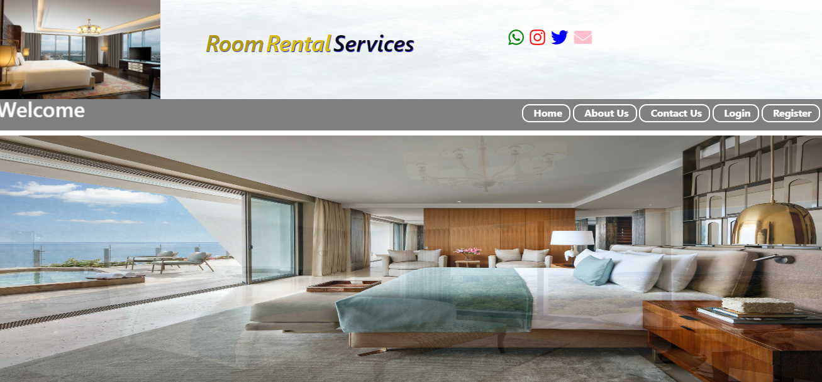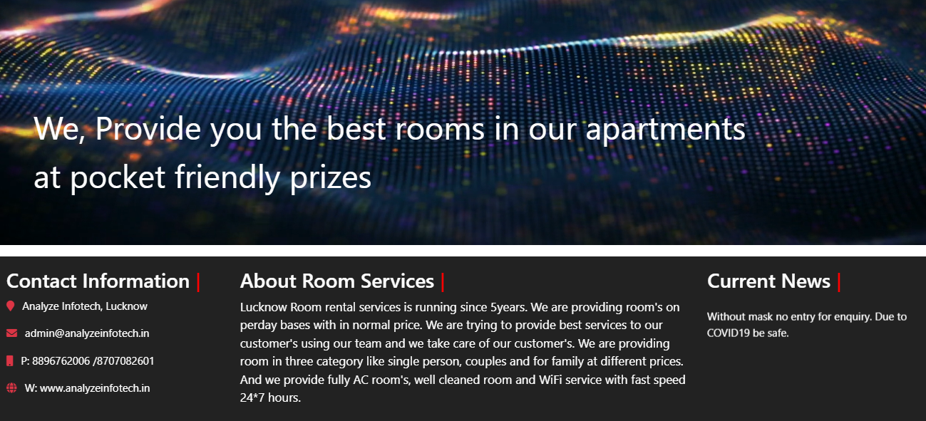

1. **Contact Us Page**

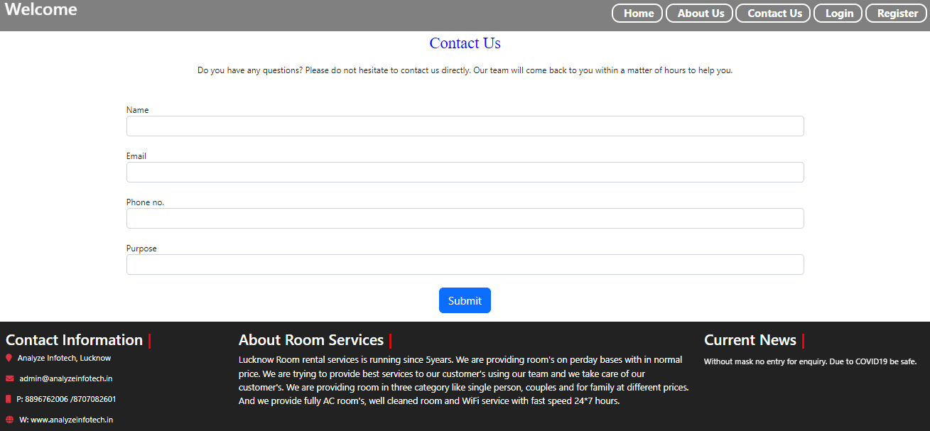

1. **User Signup**

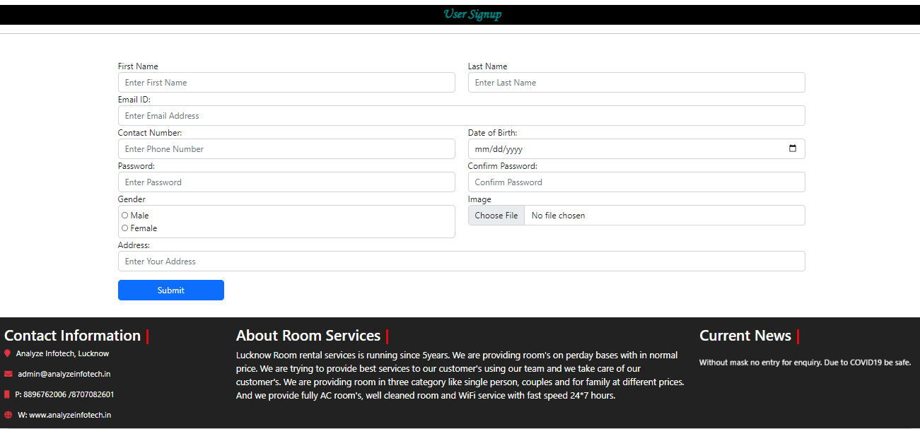

1. **Login Page**

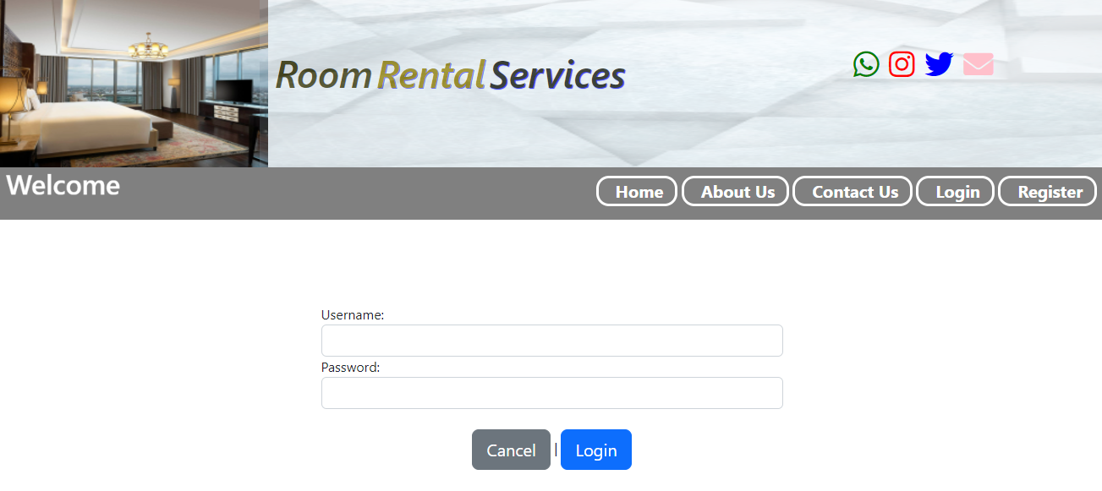

1. **Admin home page**

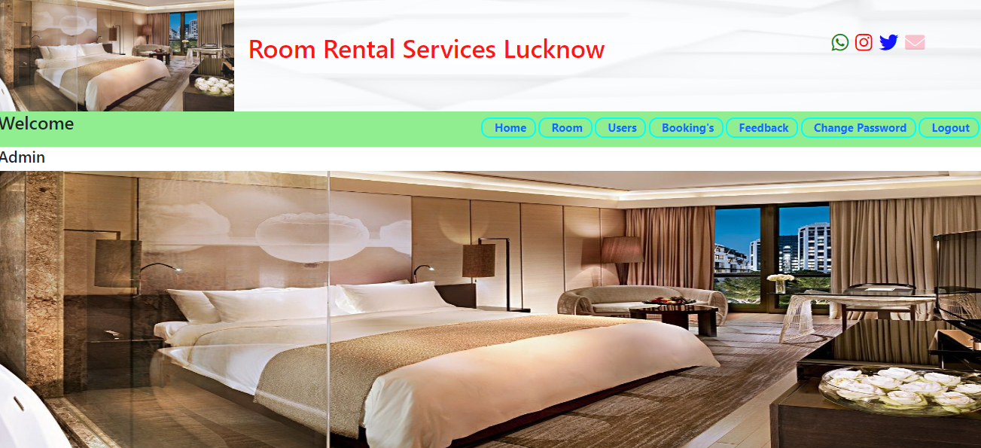

1. **View Room Admin**

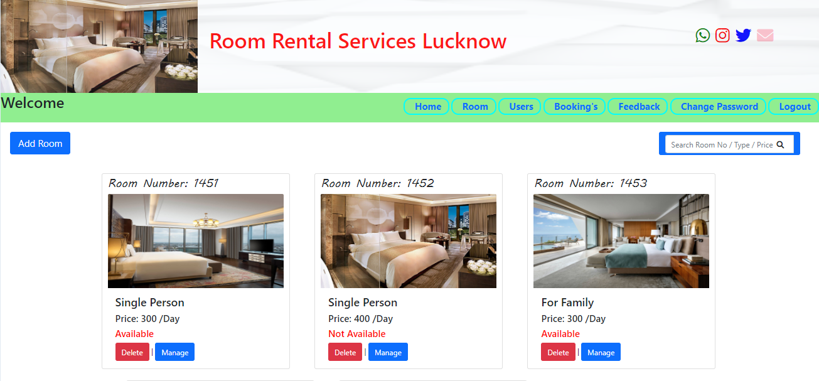

1. **Add Room Page**

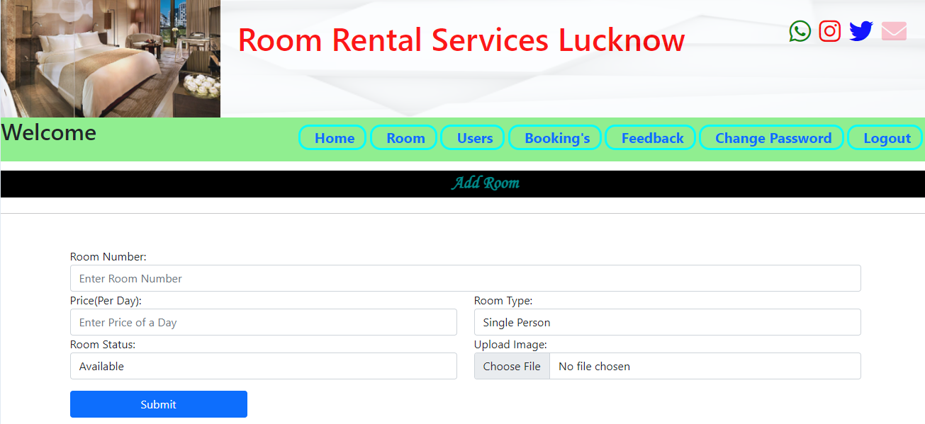

1. **Edit Room Page**

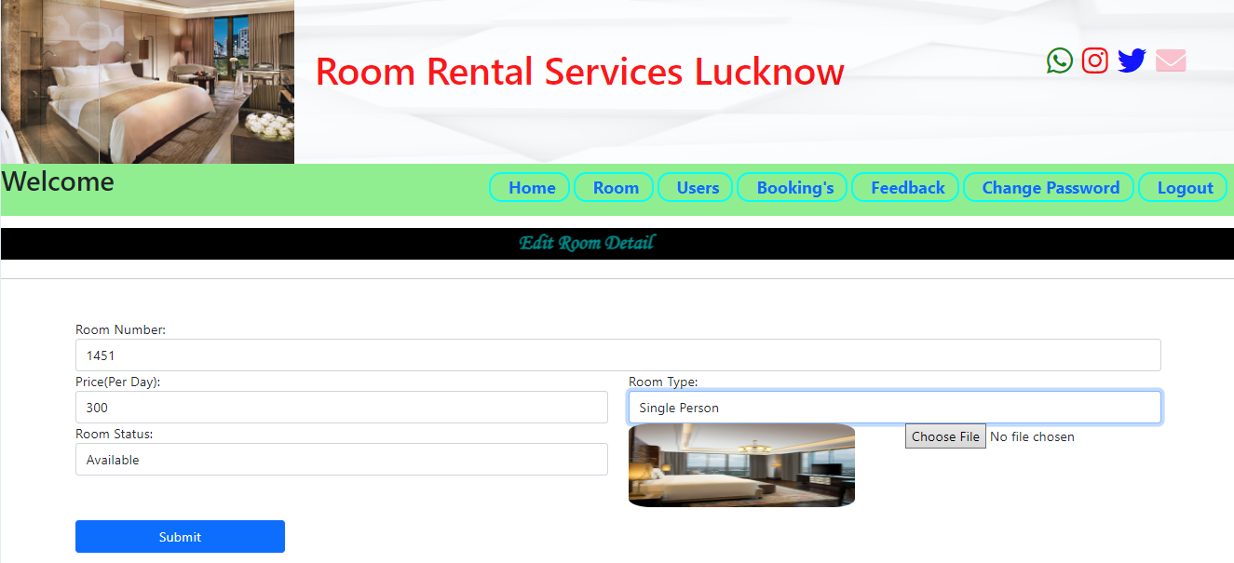

1. **View All User Page**

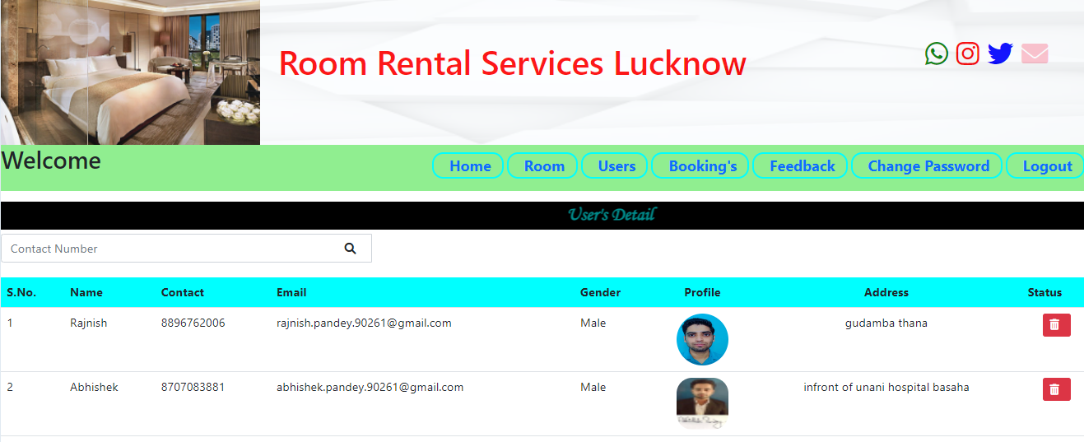

1. **View All Bookings**

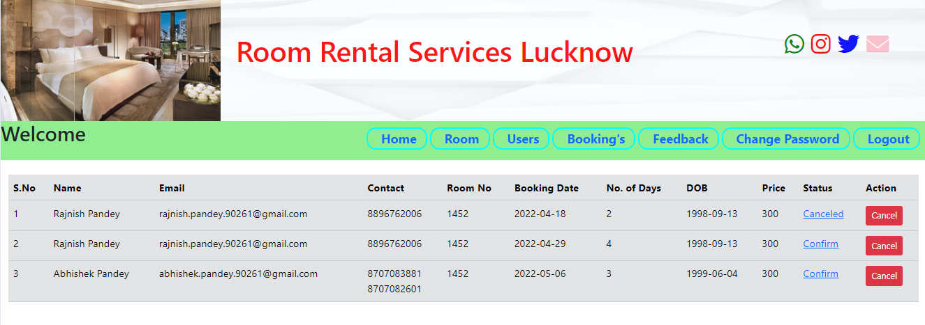

1. **User home page**

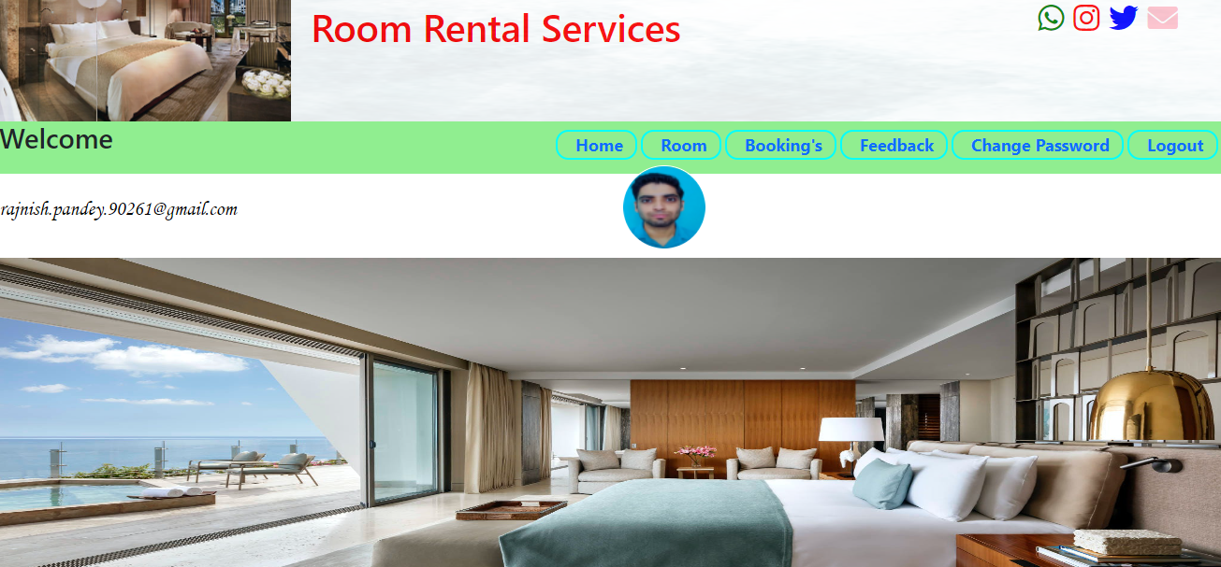

1. **Update Profile**

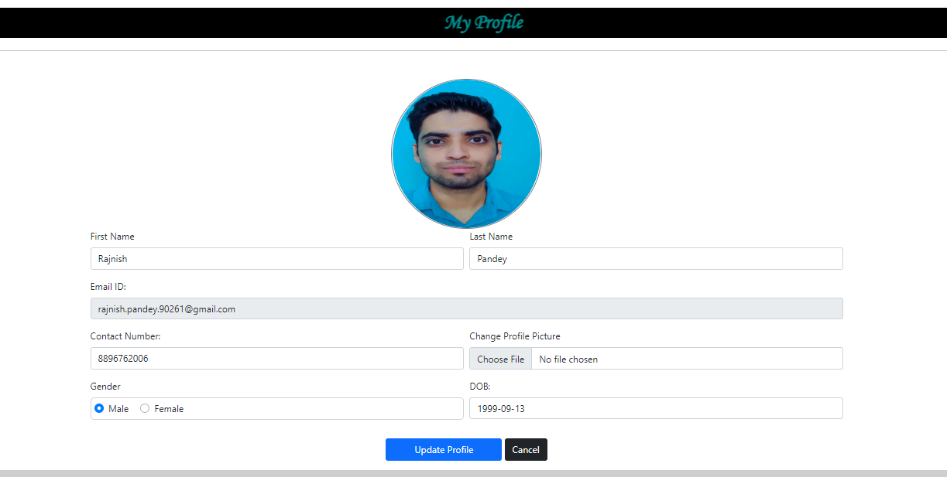

1. **View Room User**

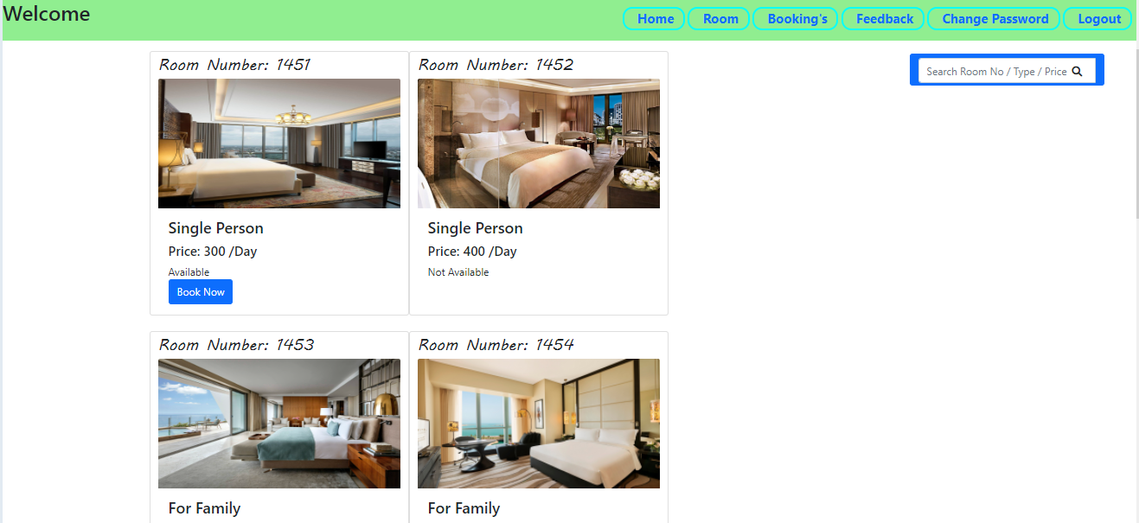

1. **Bookroom request**

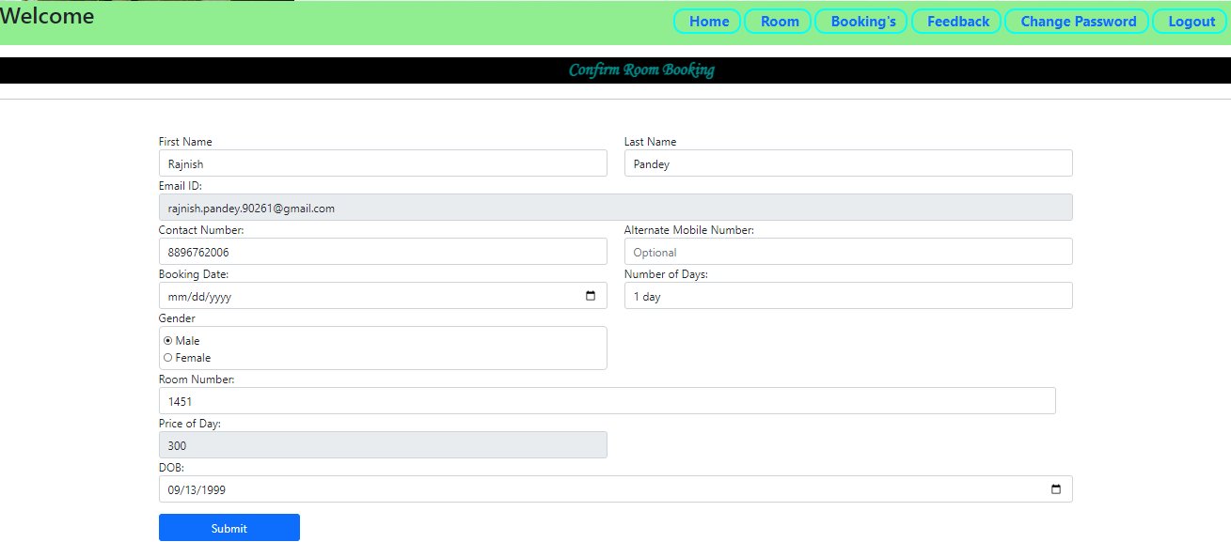

1. **View Booking**

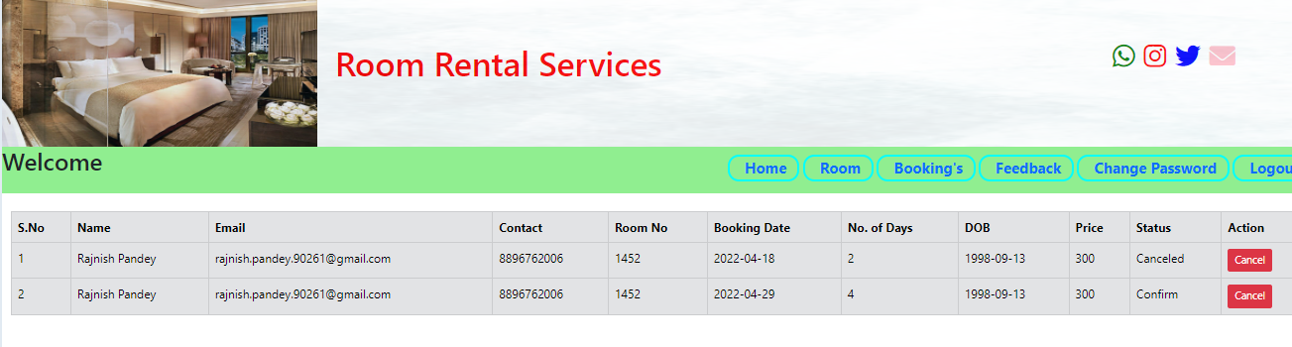

1. **Change Password**

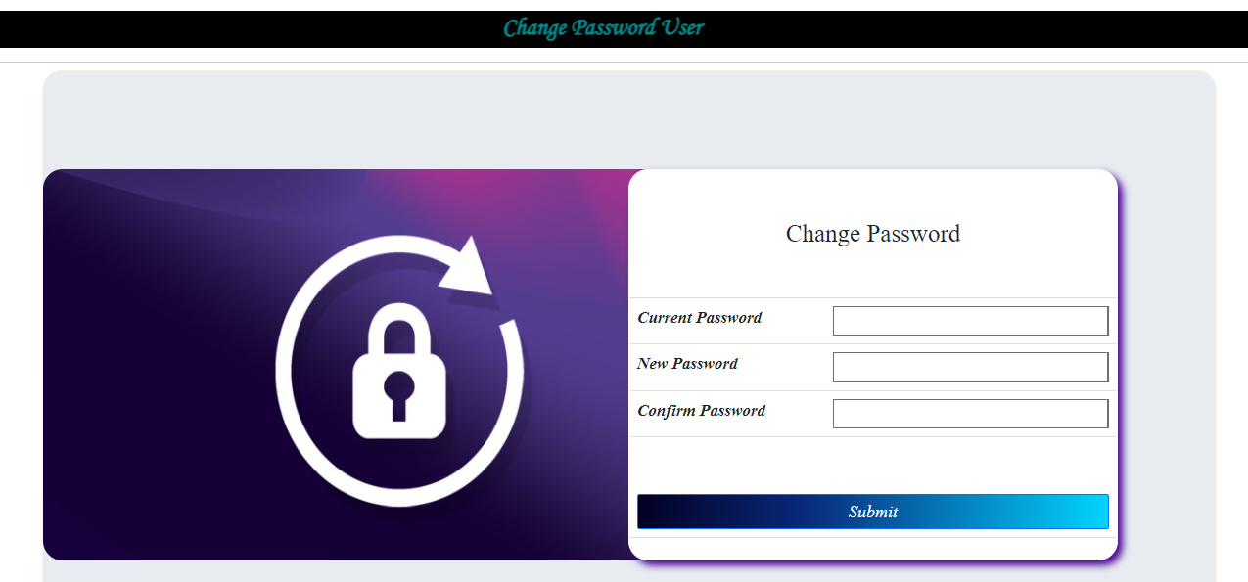

1. **Feedback Page**

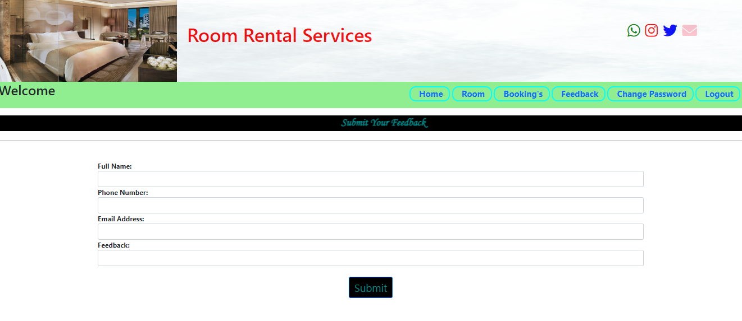

1. **CONCLUSION**

During the extended surveys about the system with different users we found different processes leading to the successful development and deployment of this system. The system doesn’t have to be expensive. It should support multiple goals of the user in terms of fast and easy way of room booking.

The basic requirement of the user i.e. to search the room and to book it is effectively fulfilled. The user can search the room on the basis of different categories, prices very easily.

Administrator that is the room renter which is the most authoritative entity of this project can manage all the functionalities of the project very easily. He/She can easily add a new room of the apartment/hotel and can easily modify it. The administrator can easily manage the details of its customers and can easily see all the bookings and new booking request. Thus it provides a great help in the report generation.

1. **FUTURE SCOPE OF THE PROJECT**

In future this project is meant to satisfy the needs of room rental. Several user friendly interfaces have also been adopted. This package shall prove to be a powerful in satisfying all the requirements of the users. It is with utmost faith that I present this software to you hoping that it will solve your problems and encourage you to continue appreciating technology because it is meant to change and ease all our work that seems to be very difficult. I don't mean that my project is the best or that I have used the best technology available it just a simple and a humble venture that is easy to understand.

In the near future we will add more and more new functionality like we can add GPS system in build and can give live chat online option to users; it can include the sms api integration. This project can also be extended to android and ios Platform and several state databases can be included. In future it can be modified, so that it can be done online. In order to meet these facility this is the major change which can be done in future regarding this project.

1. **BIBLIOGRAPHY**

**Head First PYTHON with Django & SQLITE:- By Lynn Beighley & Michael Morrison**

**The Complete Reference:- PYTHON- with Django (Guido van Rossum)**

**Django 3 By Example:- By Antonio Mele**

### Reference websites

* [**www.youtube.com**](http://www.scribed.com/)
* **www.wikipedia.org**
* [**www.w3schools.com**](http://www.w3schools.com/)
* [**www.javatpoints.edu**](http://www.javatpoints.edu/)